CYCLE OF SONGS – LEARNINGS & LEGACIES – DRAFT DOCUMENT
PRODUCED BY HISTORYWORKS ON 3rd October 2014

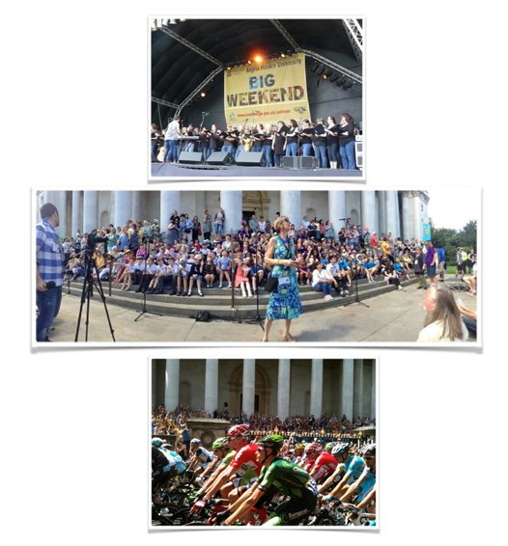

This Learnings and Legacies draft requested by Jane Wilson, Arts & Events Manager, Cambridge City Council, Chair of the Commissioning Panel for Cycle of Songs
This Learnings and Legacies draft to provide Overview, Background, Timeline, Stats, Legacy Activities and Future Partnership Funding, Learning from Evaluation with Schools: Teachers and Children, Findings & Evaluative Evidence: Artists & Singing Participants and the Publi
TITLE :CYCLE OF SONGS – LEARNINGS AND LEGACIES

This material is designed as an addition drafted to extend the understanding of the project outlined in the Cycle of Songs Report submitted by Marcus Romer. This Learnings and Legacies draft is therefore a draft and includes information requested by Jane Wilson about the background to the commissioning of the project, the findings about legacy and learning describing repeat performances and ongoing projects resulting from the Cycle of Songs. It also captures the findings requested by Jane Wilson to evaluate the experiences of the key Cycle of Songs participants: researchers, artists, schools (teachers & children), choirs, singers.
Historyworks wishes to underline that partner and panel member participants may want sections of this Learnings and Legacies corrected or amplified. It will therefore be helpful if you attend to the sections you are interested in and read it in the spirit that this Learnings and Legacies draft has been created as a draft. Please know that suggestions are welcome and do submit specific page numbers to assist with changes. It will be completed following on the Cycle of Songs panel meeting of 6th October to include the stakeholder feedback of the panel and will be finalized under the direction of Jane Wilson, Arts & Events Manager, Cambridge City Council.
Table of Contents
1. Introductory Overview of Learnings and Legacies – Evaluative Findings
2. The Outline for Cycle of Songs as a Commissioned Project
3: Timeline for Cycle of Songs month by month
4: Stats for active participants, twitter, website, audio, film, app
5: Legacy Events & Activities, Future Partnerships & Funding
6: Learning from Evaluations with Schools: Children & Teachers
7: Findings from Evaluations with Researchers, Artists & Singing Participants & the Public
8: Recommendations for Future Projects Commissioned for

1: Introductory Overview of – Evaluative Findings
The project was delivered by an equitable partnership between two organizations who came together to win the tender: HistoryWorks & Pilot Theatre. Pilot Theatre was the contracted organisation and managed the budget; HistoryWorks contracted the artists and choirs, venues and crews. The Creative Direction was delivered by Helen Weinstein, Creative Director of HistoryWorks. The Technical Direction was delivered by Jon Calver, Technical & Business Director of HistoryWorks. The Artistic Direction was delivered by Marcus Romer, Artistic Director of Pilot Theatre. Helen Weinstein was engaged as overall Producer with the Historyworks team responsible for the delivery of the assets and commissions for live performances and for their use on the app & website. Historyworks also delivered the outward facing media products of website & photography, video & audio assets. For more information about the creative team, see: http://www.cycleofsongs.com/about_us/

The brief from Cambridge City Council was to create a publicly engaging artwork to maximise the opportunity for the city to be showcased, enjoyed and seen in a new light to mark the Tour de France on 7th July 2014. The Cycle of Songs successfully created an experience for over a thousand adult singers and two thousand primary school singers with the nine new pieces commissioned, then rehearsed and performed to the public at a series of large-scale public events, and recorded for the new free app. The participants embraced the new pieces with repeated descriptions of the Cos that it was “fun” and “innovative”. Further, participants repeatedly stated the process of learning the lyrics about people

and places in the past gave them “a deeper connection to Cambridge” through the stories and sources for the songs, making them “more aware of their sense of place”.

This Learnings and Legacies draft gives an overview of the project via a detailed descriptive timeline of the milestones achieved month by month, then gives the stats for the various ways in which the participants and the public accessed the artwork via public events, and with thousands of hits on the online assets on the website pages and flickr group and audioboos, less high hits on the film and app.

The feedback from panel partners underlines that an appreciated aspect of the project has been the CoS team creating well organized opportunities to thousands of people crossing the town/gown divide, exposing residents to new experiences in university spaces, whether it be primary children singing in the Fitzwilliam Museum or King’s Chapel, a rapper taking inspiration from historical research and the collection in St John’s rare books archive, University research students working in collections, community choirs performing in unique spaces, whilst exposing the public to new commissions from top poets Inja and Dave Cohen, Michael Rosen and Hollie McNish; accomplished community choir composers Kirsty Martin, Karen Wimhurst, Andrea Cockerton and Rowena Whitehead; and internationally renowned composers Peter Gregson and Michael Berkeley.

The success of the Cycle of Songs can be measured by the large numbers attending the public events, accessing the informational website and downloading the audio and film and app.

However, the project did have some tensions because of the tight timeline & opportunities for co-creation were limited. Artists worked collaboratively with the research team at Historyworks on the history sources. Helen Weinstein led on the research to create lyrically based pieces, with crucial input and leadership from Jon Calver and the CoS Choir Director, Rowena Whitehead. Despite the time constraints, artists and choir leaders responded that they wanted to be involved because they were drawn to the concept of the Cycle of Songs and the opportunity of having top quality recordings of the pieces. Along the journey of the project a community then developed, with feedback that CoS gave a sense of belonging to residents, through the history lyrics, with unforgettable community activities in city and university locations, and enjoyable participatory events inside the fantastic art spaces at The Fitzwilliam Museum, Cambridge Junction, Colleges, and Kettle’s Yard.

Partnership projects have developed with Historyworks partnering many of the artists, choirs, schools, university departments, and GLAMS on future projects. It is hoped that these relationships can develop from the somewhat instrumental relationships for the Cycle of Songs to ‘real’ equitable partnerships, and that the participation on the next projects can also involve more co-production and co-creation.

This Learnings and Legacies draft details the legacy of the CoS project, showing how the artworks have been appreciated, with repeat live performances by Cambridge choirs of seven of the nine CoS pieces scheduled thus far. Schools involved particularly appreciated the project, with the learning being that children enjoyed the playful method to sing about the past, and liked it most when children were given the opportunity to be learning from other children. Next projects might embed this finding, and reach out to schools with culturally disadvantaged pupils, to neighbourhoods with less culturally networked families, and offer further pathways to a sense of cultural entitlement, especially in all that Cambridge has to offer for expressing and experiencing a very wide range of artistic and cultural events and activities.

Timeline and Description of the Project

For the purposes of this document it will work through the timeline of the project and will have live links within it - so this will be most effectively used as an onscreen document rather than a printed copy. The links will be live in this Appendix which will lead to the relevant online pages of documentation and images.

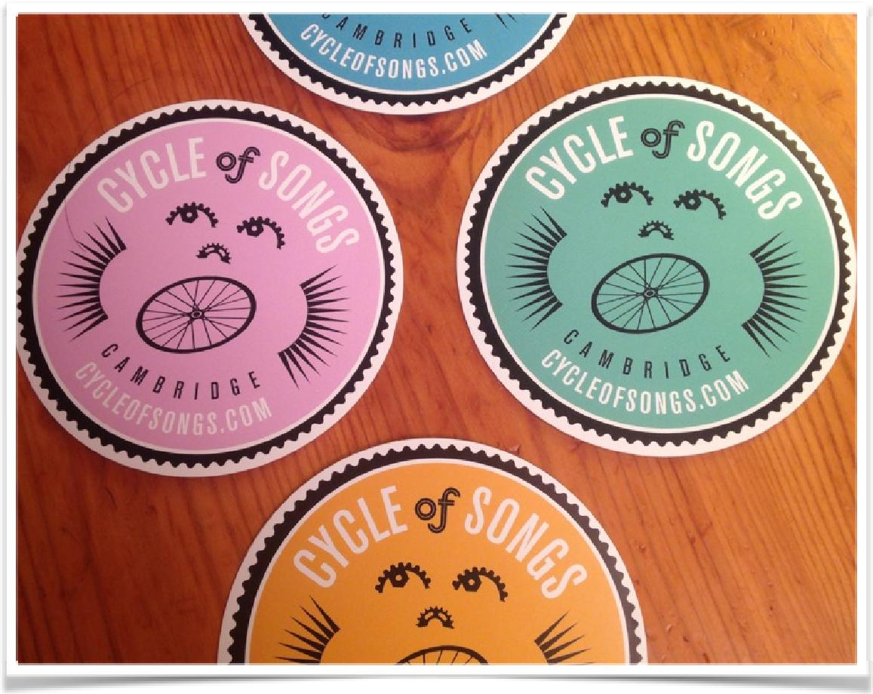

Background and the Tender Commission Process for CoS

The Cycle of Songs Project was a commission by Cambridge City Council, funded by Arts Council England. Historyworks moved to Cambridge in 2013 and after a series of Autumn talks and workshops offered to Arts practitioners and Heritage organizations in Cambridge to explore history trails, soundscapes, and app technology, it followed that Helen Weinstein, Creative Director of Historyworks, received an invitation on 11th December 2013 from Elaine Midgeley with the invitation to tender for the Tour de France Arts Commission. See Making Heritage Mobile blog at CycleofSongs website here: http://www.cycleofsongs.com/news/#making-heritage-mobile

Historyworks invited Pilot Theatre to team up and develop an idea to create a musical history experience around the Cambridge TDF route delivered through a soundscape of unique and bespoke commissions performed by local people, informed by historical storytelling. During the development phase, Helen Weinstein as Creative Director of Historyworks, and Jon Calver as Technical and Business Director of Historyworks, contacted and met with a range of the Artists – composers and poets – to scope potential talent to be involved with the big idea of commissioning pieces based on historical sources. Helen also met with a set of local history professionals and heritage practitioners to discuss how best to create an experience that would enhance Cambridge’s sense of place.

Helen Weinstein, as a professional historian, in addition to being the Creative Director took the leadership for identifying the key history stories and potential artists for co-creating the pieces, and when Marcus Romer of Pilot Theatre came on board on 4th January for the first partnership meeting to shape up our tender bid together and walk Cambridge’s Tour de France route together, a large number of potential stories had been scoped, and many of the potential artists contacted. What was needed for the project was an ambition of scale, which is why Historyworks approached Marcus Romer.

Jon Calver, Technical and Business Director of Historyworks agreed that having experienced the production of Pilot Theatre’s “Blood and Chocolate” first hand on the streets of York, that teaming up with their Artistic Director, Marcus, offered the prospect of creating a winning project for Cambridge. And so it was agreed that we would use the history storytelling and community project building expertise of Helen Weinstein, with the audio recording production and editing technical expertise of Jon Calver, to a scale and ambition made possible by the live expertise of Marcus Romer.

Following our pitch to the panel on 28th January, and being told of our winning the tender on 30th January, it was therefore decided that the project would be delivered by an equitable partnership between two organisations: - HistoryWorks and Pilot Theatre. The two organizations would follow the Arts Council England strategic policy for “Supporting Participatory Practice” and “Equitable Partnerships”. For VAT Accountancy and Administrative reasons, it was mutually decided that Pilot Theatre would be the contracted organization for this Arts Commission with Cambridge City Council, and we went forward using a contractual MOU to allocate the budget and tasks: Historyworks taking all the responsibility for the contractual and consent and creative negotiations with artists, performers, venues; with Pilot Theatre overseeing the payments, branding, & marketing and overall budget.

From February 2014 onwards, because of winning the tender, Historyworks committed to further face to face meetings with the collaborating composers and poets in order to shape an understanding with key Artists about how we would co-create and compose pieces based on historical sources. This was to be the building block for the project, and without these early meetings to talk through the co-creation practice and to scope the interest in this methodology of inspiring the commissions, it would not have been possible to pull off working with top artists in such a short timescale.
So with the tender won, it was agreed that the production tasks would be delivered by the Creative Director of Historyworks, Helen Weinstein, amplifying her role of shaping the research, commissioning the artists, working with the choirs and musicians, realizing the partnerships for events and venues, organizing the live performances, and delivering the website and the photography and film assets. It was agreed that Jon Calver as Technical Director would manage the delivery of audio assets, the essential recording and editing elements at the heart of the project to support the choir leaders and singers up to and including the performances for the app and for the live events. It was agreed that Marcus Romer, Artistic Director of Pilot Theatre, was to manage the app delivery contracted to the company Calvium, and would shape the overall branding and marketing and press and messaging of the project, including working up the team’s final report to the funding panel. (See Contractual MOU attached at end of this document).

2. The Outline for Cycle of Songs

This was to be a series of events: live performances, rehearsals, recording sessions - which would include:

An ‘album’ called a “Cycle of Songs” - with 9 newly commissioned pieces of work, would be delivered - inspired by historically informed storytelling with lyrics based on original sources researched about people and places located along the TDF route in central Cambridge.

These would be choral and spoken word pieces that would allow participation from history research volunteers and singers & poets in the city to work with key producers provided by Historyworks facilitating relationships with the composers to develop and share these works with local singers and musicians.

These commissions would be by a range of artists to deliver a diverse ‘album’ of deliberately different content, inspired by the researched stories along the route

There would be live performances by the choirs, that would include celebratory launch events to share singing and performances across musical traditions in Cambridge, a specially convened ‘scratch choir’ for the duration of the project in order that individual singers could actively participate in our ‘Cycle of Songs pop up choir’ building a community of singers through rehearsals and presentations and performances, culminating in the Big Weekend on Parker’s Piece and a performance on the race day itself, July 7th, where there would be an event to celebrate and sing together as the cyclists passed through the city.

To support and help build community between singers, musicians, poets, composers, choir leaders and the production team, a bespoke website was coded by Historyworks’ web designer Rick Taylor to house the commissions. This would prove an important resource in supporting the singers (who mostly learn by ear and do not read music) to learn the new pieces in a short timescale by providing sound files with notes about the history stories to provide the context, and a series of photographs for every rehearsal and event to share with the community of participants. The website was designed to create a community with a shared mission, with interested parties and press all able to read about the historical research and the composer and poets responses to the source materials. All this would thereby underline the project’s vision to enhance Cambridge’s sense of place and celebrate the diversity of people in the past and the present. The website was an efficient way to share information about rehearsals as well as the pieces, so that this digital asset could be a first place of reference for those involved or interested to learn more about the project. It has also housed the photography and filming of the project and acted as a fitting legacy.

To tempt the public in Cambridge to engage with new technology, and as a legacy, an app would be built to be a mobile version of the Cycle of Songs website, to house the commissions as an album which would be freely accessible. Most importantly, the Cycle of Songs app would create a means for listeners to walk or cycle the route to enhance their sense of place, because the pieces would be geo-located within the areas from where the stories emanated from, thereby allowing an immersive and interactive experience as a digital legacy for the City.

2a: Additional Assets for Cycle of Songs

There would be a commissioned piece of visual artwork to celebrate and act as a marker for the Cycle of Songs project and the events and locations for the City.

There would be a broadcast quality short film made by Historyworks’ Creative Director, Helen Weinstein, to showcase the project, offering a synopsis of the nine commissioned songs, the choirs and artists that recorded them, and the route the Tour de France took through the locations in central Cambridge, suitable to be played on a variety of devices, from a phone screen to a film screen, enabling the project to be showcased on completion.

There would be a flickr photography project associated with the Cycle of Songs website, that would be set up and managed by Historywork which was to prove a very popular asset for the community of participants and partnership venues and organizations, allowing them to source illustrations for newsletters, blogs, websites; and useful for the Press who were also allowed to publish the photographs in return for a courtesy credit, under the conditions of Creative Commons License.

As part of our shared aims - we wanted to deliver a wide ranging participatory element to the work, allowing any volunteer community member to become a historian to join in with our team of researchers led by Helen Weinstein, and any singers or helpers to join our Cycle of Songs ‘pop-up’ choir, led by a specially commissioned Choir Director. We were careful to scope potential choir leaders, and a big success of the project was in our persuading a dynamic choir leader to join our team, with the appropriate skill set to lead singers who might be singing for the first time, and/or learning by ear, unable to read music.

The Cycle of Songs Choir Leader appointed in this role was Rowena Whitehead who was tireless in her coaching and working with singers throughout the rehearsal, recording and performance schedule. The Cycle of Songs Choir learnt two key anthems for the singers to perform together with Primary School Choirs as part of a series of Cycle of Songs events. A pop-up ‘flashmob’ event in the City Centre (planned by Marcus for 21st June), as well as the live events on the 5th July at the Big Weekend at the Cycle of Songs marquee and at Sing&Swim in the evening at the Jesus Green Lido, culminating in the “Song Fest” on the Steps of the Fitzwilliam Museum to sing to the TDF cyclists and the public on 7th July. This series of live events was delivered in response to the guidance from our Commissioning panel, who were keen to have the Cycle of Songs project singing publicly about the TDF route.

As the project developed, the team gave singers a transformative experience by enabling them to use their voices in unique spaces with rehearsals and recordings taking place in iconic locations across the city - so for the Cycle of Songs Choir, Marcus Romer led on utilizing the support from our partners in the city, for the ‘popup’ Choir to rehearse at Kettles Yard, Cambridge Junction, The Fitzwilliam Museum and Cambridge Guildhall; - whilst Helen Weinstein led on organizing the venues for the huge variety of community choirs and school choirs - enabling them to team up with University musicians to rehearse and record in spaces such as King’s Chapel, Great St Mary’s, Emmanuel College Chapel, and the Recital Room and Concert Hall at the Music Faculty on West Road. As such we were able to rehearse, record, or perform in a great array of places in Cambridge, and to enhance a sense of belonging from residents interacting with arts and heritage spaces including:

Kettle’s Yard

Cambridge Junction

The Music Faculty Recital Room and Concert Hall

Great St Mary’s Church

King’s College Chapel

The Fitzwilliam Museum

Romsey Mill Community Centre

Castle Hill Mission Hall

The Guildhall

St John’s College Archive & Rare Books Library

Emmanuel College Chapel

3: Timeline for Cycle of Songs

January

January was the time when Historyworks sought out a Choir Leader for the project in Cambridge and scoped the involvement of Rowena Whitehead, leader of ReSound and Global Harmony, who gave invaluable advice to Helen Weinstein as Creative Director about how best to create a project that could be participatory for individual singers to join a ‘scratch’ rehearsal and performance choir, and together invite Choir Leaders to persuade their entire Choirs to be involved in the recordings & performances. Helen Weinstein also met with a range of local historians and history groups both in the city and the university to scope how they would best become participants in the project over the following weeks.

In addition, Jon Calver and Helen Weinstein continued follow-up from their scoping phone calls from December, to meet face-to-face in London during January prior to the bid, so that we could name particular composers, like Michael Berkeley, and upcoming musicians, like Nick Mulvey, and Cambridge word activists like Hollie McNish so that we could guarantee buy-in from them to be named in the tender commissioning documentation and our bid presentation to the Arts Commissioning panel.

These approaches to Artists were developed by Historyworks during January to be followed up in February with more detailed and longer meetings with top Artists like Michael Berkeley and Michael Rosen, Karen Wimhurst and Kirsty Martin, all of whom were attracted to the idea of co-creating new works based on historical sources and were sympathetic to a project catering to the skillset of community choirs. This was necessary so that Helen Weinstein could start shaping up the short list of History stories to co-create the lyrics for the compositions, so that the research would be targetted.

February

The website holding page was built outlining the ethos of the Cycle of Songs - and whilst the team at Historyworks was shaping up the creative content of the project and meeting choir leaders to get their buy-in, in parallel we went into the contractual negotiations with Cambridge City Council - awaiting our contract and agreeing the sign off took quite a long time.

One learning point for all of us was the two stage commission procedure. So, getting the commission, then the contract and an initial £4k payment for us to work up the idea was not the most useful of mechanisms. Until we had the go ahead we were still unable to green light contracts for the Artists and the Choir Director, and the Administrator/Scheduler approached. This meant that the core creative teams were in effect working with HistoryWorks taking responsibility and shaping work in archives and with artists with whom they had previous working track record - and recruiting choir leaders and musicians in Cambridge who were attracted to Cycle of Songs because of the offer of working with a team that could deliver to them a BBC quality rehearsal and recording experience; and Pilot Theatre likewise was developing existing relationships for press and marketing and branding for the project.

This too had a knock on effect between Pilot and HistoryWorks - as clearly only once we had sign off from the Council could we then thrash our contract between both parties to agree tasks, roles and responsibilities. This meant that Historyworks had to finance the project from December onwards with almost 4 months of unpaid work, leading de facto to Helen Weinstein as overall Creative Director of the project and paying for this too, because all the co-creation of the project with commuting to work with Artists in London, hosting of musicians and choir leaders in Cambridge, visiting archives and hosting gatherings of historians to work up the stories between the end of December and the end of April went forward with no specific agreement and no money coming through to Historyworks until the first payments from Pilot Theatre were made on 28th April.

This meant that by the time we got to the end of March when the Council signed off, we still had not finalised all the paperwork between all parties, which lost us two months from the point of offer to the point of Marcus Romer settling to a role in the project in relation to the leadership already provided by Helen Weinstein as Creative Director and Jon Calver as Technical Director at HistoryWorks. However, fortunately, there was an upside to this, in that Marcus Romer as Artistic Director played a crucial leadership role in championing the use of new technology within the team and for the public, doing all the liaising with Calvium and the testing of app drafts, and this took a huge burden away from the rest of team to ensure a successful delivery.

March

March was the month, even though we still hadn’t signed off on the final commission with the City Council for the Arts Commission, that Helen Weinstein drilled down into the history stories, convening open meeting at local cafes and libraries, working with local history group volunteers and teams of University history research students.
Costs started to really mount up for Historyworks, paying for photography and archive work to prepare for the bespoke website and app, and the hosting of day workshops for the volunteer participants involved at cafes, and concretizing the relationships with choir directors, and working with the composers to collaborate on the content and shape of their pieces. Because it was taking time to get the funding through, we built all of the materials for the composers and poets to use on the Historyworks website, importantly including words from original sources for the artists to use for their co-creation work with Helen helping them specifically to select the ideas and words and feelings that spoke to them about Cambridge people and places. By the end of the month, as Creative Director, Helen had kept to schedule of cataloguing and writing up the stories from the key geo-locations.

Essential to completing this task and preparing for the intensification of recruiting local people to join the project, was the hiring of Sam Johnson, to work alongside Helen and Rowena to support the project as administrator for Cycle of Songs. Sam had worked to support Historyworks on numerous history and broadcasting and app projects in York and London over the past year, and therefore had the skill set to rapidly fit in to support Helen to prepare the Cycle of Songs website and app content, work alongside Jon to label sound, film and photography files, and support Rowena to draft all the invitations to singers to join the choir, and start the database of choir directors with the rehearsal times and capacities of their members that was to prove an essential tool for the success of the project, kindly and carefully supporting the singers with emails, information, useful updates.

We launched the project at the end of March bringing together 80 participants for a workshop and celebration with a fantastic mix of artists and choir directors, practitioners and partners, local historians and research students at Hot Numbers cafe on March 31st 2014.

To heighten the success of the launch and to have a pay back to the volunteer history team, we offered a “History and Media” workshop open to all before the party part of the launch at Hot Numbers. This comprised of an overview about narrative formats, with Jon Calver speaking about the landscape of radio commissions, Helen Weinstein on TV, and invited speaker, Paul Lay, Editor of History Today to talk about commissioning in the publishing industry, and Marcus Romer giving a conclusion to the workshop part of the event by outlining the Cycle of Songs project. For entertainment, Helen booked the Searle Street Band, a very talented group of post doc researcher/performers. Additionally, the Steak and Honour burger van was booked for those who needed gourmet locally-sourced food. After all it had been Hot Numbers that had hosted so many of the working meetings of the project up to this point, so it was apt for the launch for our partners to be at this venue, and it helped get us off to a good start in the community, with great pictures by student Janine Noack – see:
http://www.cycleofsongs.com/news/#storify-1

April

We did have some difficulties in March having to be careful with our Artists because we were not able to offer concrete contracts. However, we only ‘lost’ one Artist who had pre-agreed at the bid stage to be involved, and this was Nick Mulvey, but was much more to do with Nick’s sudden rising success as a new voice of Radio One/Six Music, than our not being able to offer him a specific recording and gig date and fee to secure his participation at this stage of the project.

By April we were coaching all the composers with their pieces and Helen Weinstein, as Creative Director, with the support of the media lawyer Ian Bloom, who had been engaged to advise the project, sent out draft contractual documents, for the artists to commit to their pieces and to know which voices they would be composing for. Helen devised agreements so that all the composers and poets signing off on their contracts had to submit a one page biography describing why they wanted to be involved with Cycle of Songs, describing how they were going about composing their piece, with two illustrative photographs, including a head shot. Their payments would also only be available on the production of these materials and a draft mp3. This helped us filibuster until the funding came through and also provided a useful focus for our choir leaders because they could read up about their match for an Artist in emails we sent to them and their singers, providing a lovely start to the co-creation and sharing ethos of the online project.
At this stage, the Cycle of Songs bespoke website was being built offline with restricted access but was developing well to be offering both history content and musical content, as Sam supported by Helen shaped up and uploaded the materials coming in from Artists & Historians, giving a narrative about the process by which we were all working on the new commissions, carefully shaping the content that participants so enjoyed and the press found super useful.

In addition, Rowena Whitehead was guiding the Cycle of Songs team so that the events would suit the types of choirs and singers we wanted to reach out to, particularly beginner singers, and singers who needed to learn to sing pieces by ear, rather than those who were well versed in reading music and the landscape of a traditional choir.

The core team of Helen and Sam became adept at writing letters to explain the ethos of the project, and drafted invitations to join the Cycle of Songs choir which Rowena sent out to all her contacts via ‘Talking in Tunes’ and we started to build a database of choir leaders to contact, with Helen and Rowena sending these invitations out jointly from a newly set up cycleofsongs gmail account, so that the correspondence could be shared, and gradually the administration of the account taken over by Sam Johnson as he learnt the project.

Rowena also approached a range of community choir leaders to invite them to participate in a launch event. Unfortunately it was too soon for choirs to be singing the specially composed new pieces, so instead we planned an event for musicians to play and choirs to sing a couple of their favourite pieces to one another. This was found to be an event which rarely takes place in Cambridge: the coming together and celebration of voices for its own sake, which we wanted to embrace.

These invitations were followed up by Helen during the month of April, taking a lead on choir wrangling; because it had always been the case that Rowena would be abroad for much of April. Although Helen had had no track record in this area in Cambridge, it actually was a good excuse for her to create a new network and to reach out inclusively to a wider range of musicians and choirs from groups that do not normally perform in the same place. Helen used the Mill Road Winter Fair brochure listing community group performers and asked many people for their contacts, in order to reach out to groups such as the Indian Music group called Sur Taal and Chela, the Georgian Singers, who were pleased to become involved with Cycle of Songs.

Therefore, a rough running order was shaped up by Sam in April to prepare for a May launch in town, and Helen’s time was very busy meeting with Choir leaders to both engage them with the potential rehearsal and recording schedule for the app in May/June in addition to securing their participation at the 11th May launch event. To support this reaching-out to new choirs, Sam was creating an online resource, asking choirs for descriptions of their capacities and rehearsal venues, so that we could upload these materials to both help the composers learn about their choirs, also hoping people coming to the website might join a choir once provided with this information. For a venue, Helen persuaded the rest of the team at Cycle of Songs who had been skeptical, that Great St Mary’s could be a perfect partner with the heritage officer keen to develop this type of relationship and support a history project, and the Cycle of Songs needing a central venue that could hold 300 to 400 participants and be very open to the public walking into the venue and joining in on spec.

During this time Marcus was working on the branding and identity for the project with Mat Lazenby and came up with variations of the Cycle of Songs bike parts logo of the singing face for us to sign off on. For us this summed up the project of being of disparate and diverse parts coming together as in a bicycle to make us move forwards in the same direction of travel.

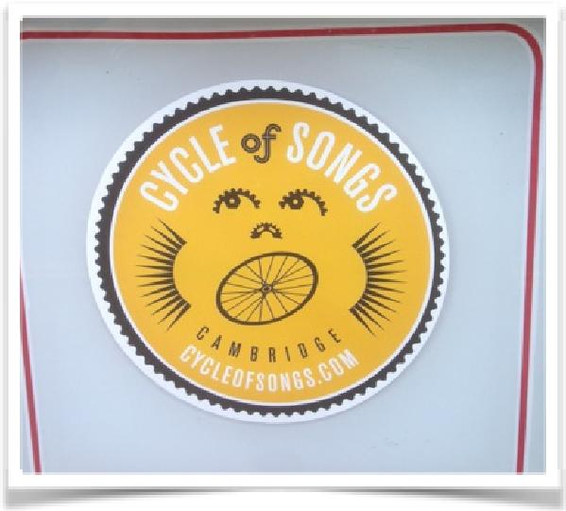
We managed to get permission from the Council to used these new +ve charged stickers - which were ‘non-sticky’- to be used on the existing street furniture in the city to help to promote the project and the app.

So these began to be placed at the geo-location spots for the songs and pieces for the sound walk

In addition, Helen Weinstein learnt more from Liz Hughes about the Vitrine Scheme to mark the Tour de France, and started to explore possibilities with the John Lewis store to donate one of their window spaces using our sticker designs as their motif in order to create a special window display celebrating the Cycle of Songs by inviting people to join in our events and our ‘popup’ Choir, which was published as a vast vinyl on the Downing Street side of the store during June and July, advertising the CoS project and website to passers-by.

May

By the start of May, the project was settled contractually and Historyworks knew that they could proceed with turning the draft contracts into concrete offers and as draft sound files and descriptions were received, this beautifully shaped up as rich content for the website ready for the launch – with signup areas for volunteers and singers as well as areas for Choirs and Composers. Nicky Buckley advised Helen Weinstein on press contacts, and the visits Nicky facilitated for Helen on the ground to meet with Chief Correspondent, Chris Elliott at Cambridge News, and Sue Dougan at BBC Cambridgeshire meant they became interested in the project, and habitually covered the Cycle of Songs project between May and August.

Meantime, gearing up for the May public launch at Great St Mary’s, the Cambridge Choirs and Musicians we worked with and contacted who came along and joined in as entire choirs or otherwise sent singers along to participate in our launch events and rehearsals included:

Addenbrooke’s Hospital Choir

Cambridge Music Education Outreach

Cambridge Revelation Rock-Gospel Choir

Cambridge Ten Sing

Chela, the Cambridge Georgian Choir

The Dowsing Sound Collective

Global Harmony

Great St. Mary’s Church Choir

Good Vibrations

King's College Choristers

ReSound

Sing!

The Spinney Singers

Shout Aloud

Sur Taal, Indian Music & Dance School

The Chapel Choir of Selwyn College

Women of Note

Many of these choirs, such as Dowsing for Sound Collective, and the Revelation Rock Gospel Choir sung at the 11th May launch event and were performers for bespoke pieces on the Cycle of Songs ‘album’ of 9 pieces for the app. But some of the performers, were recruited specifically for an individual piece. For example, with the guidance and steerage of Rowena Whitehead we also convened the Infinity Choir for Peter Gregson’s piece ‘Infinity’ with singers mostly recruited from”Women of Note” and “ReSound” but also choir leaders themselves had a chance to sing with one another in what was quite a challenging piece and a very rewarding experience for all involved. See
http://www.cycleofsongs.com/news/#blog-post-from-heritage-at-great-st-marys-cambridge-sings-for-cycle-of-songs

And of course our Cycle of Songs ‘pop up’ choir was discussed and the format shaped up by Helen Weinstein listening and learning from Rowena Whitehead about what would work best for a rehearsal choir that would be meeting to participate and perform in Cycle of Songs events, and this was made up of individual singers from various choirs as well as some for whom this was the first time they had got involved in this form of participatory activity.

Over the period from 11th May when we officially launched at Great St Mary’s until our last event on 7th July at the Fitzwilliam Museum steps, our choir slowly grew from a start of 60 in May, increasing to 80 by the time of our first rehearsal at Kettles Yard on 4th June expanding to 130 active participants by the time of our July performances.
In addition, we had a total of 1098 singers and musicians and performers who were involved in our events and recordings. Furthermore, during the month of May, Helen Weinstein developed and concretized the number of school participants, so that by the end of July we had close on 2,000 primary school singers who had learnt or engaged with the new commissions for the Cycle of Songs choirs.

Helen’s commission of Horrible Histories’ songwriter, Dave Cohen, for the songs about Thomas Hobson, proved a real winner. And the provision of web resources for teachers about Cambridge local history and Helen’s visits to school assemblies provided a huge hit for the schools and teachers involved. All this was happening as we were gearing up for our launch on May 11th at Great St Mary’s Church and it was very pleasing to learn that our talking to choir directors to come up with a unique format for choirs to sing to one another was well received, and it was proving to be a very useful hook to invite the public and potential singers to come along and visit the project and sign up for our ‘popup’ choir that would be meeting to rehearse and perform in June and July.

So we had postcard flyers made and posters with the info about this event and used this as an informational card with all the rehearsals and public events listed for May, June and July, inviting the public to join in the project to come down and participate on 11th May or at the following rehearsals and events.
The details on the postcard are here: http://www.cycleofsongs.com/news/#cycle-of-songs-postcard

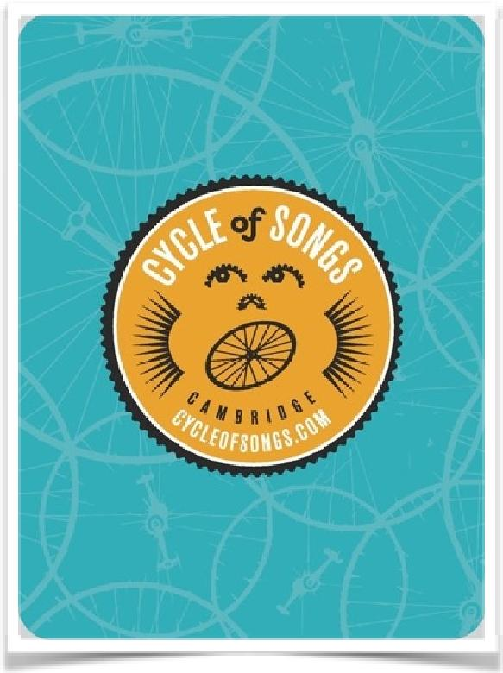

For the 11th May event, Helen had worked to direct the web designer, Rick Taylor to make a bespoke quality website with sign-in areas for participants and easy to update pages for the all important resources pages providing the demo music files to make it easy for the singers to learn their parts. Also the choirs had their pages ready for this deadline to showcase their work.
The composers were working at different paces, but the first piece for the Cycle of Songs ‘popup’ choir to learn, called “Why We Ride” was ready in vocal parts and as a whole mp3 demo sound file by the time of the launch of the website ready for 11th May. Initial filming could take place that day and in addition, Helen and Rowena and Jon were able to listen to the capabilities of the singers, listen to choir leaders about their availability and hear the choirs perform on 11th May, which helped with matchmaking for the June recording sessions for the app pieces.

The stories were shaping up well into new compositions for the choirs to learn, and Helen worked with Jon and Rowena to listen to the draft pieces sent in by the composers as demos, and helped the composers when needed to shape up the historical content and add further words to make the songs entertaining and unique for Cambridge.

Each piece would have an apt title summing up the story and a geo-location suitable for the app, all suggested by the Creative Director, Helen Weinstein in conversation with the relevant lyricist or composer. On occasion, these shifted, for example, Liz Hughes alerted Helen to the fact that Hobson’s Conduit was on a very busy roundabout and accident blackspot for cyclists and pedestrians, so this location for the Hobson story was pulled back to St Catherine’s College the location of Hobson’s horse stable business in the late sixteen hundreds.

Also, one composer, Karen Wimhurst wrote a piece about Parker’s Piece for The Dowsing Sound Collective which did not suit their style, so Rowena and Helen and Jon had to consult carefully together to find a fair way forward, which ended up with Helen creating a better match make with Karen Wimhurst to work with the lyricist, Dave Cohen and the primary choir leader with whom she had worked before, Anna-Louise Lawrence for the Hobson’s Horses piece. This enabled her original commission of writing for the 120 singers at Dowsing to be allocated instead to Andrea Cockerton, the leader of Dowsing. Under historical guidance from Helen, Andrea worked very swiftly on the brief and the content and this proved very successful with the choir members having great fun shouting out “bolting biscuits” and “smashed for six!” and other similar lines that pertained to the historical sources describing communal events at Parker’s Piece from the 1700s to the 1900s. It was interesting in the informal feedback from the choir at their recording date, to learn how many choir members did not before know about the Parker of the Piece, and really engaged with learning about the history. See the blog about their rehearsal and the short film about their experience recording for Cycle of Songs here:
http://www.cycleofsongs.com/news/#blog-recording-dowsing-sound-collective

If the Cycle of Songs project had not been under such severe time constraints, we could have had more co-creation with the artists and their choirs, but with these time scales, the composers had to work most closely with the production team at Historyworks, most often having co-creation conversations with Helen to hone the historical sense in the lyrics, with Jon about musical complexities, and with Sam about illustrative inspirations to see the places over time in engravings and photographs. The guidance offered by Rowena Whitehead throughout this period of composition for our singers was invaluable, and the mutual learning greatly enriched the quality of the experience for all involved in the co-creation, rehearsal and recording processes.

So the geo-locations for the stories were now fixed as -

Parker’s Piece

104 Regent Street

Emmanuel College

St John’s College

The Senate House

King’s College

St Catherine’s College

The Fitzwilliam Museum

The Botanical Gardens

We wanted to tie in with the concept of 9 lessons and carols so - to use 9 stories and songs for our project was key.

The identification of the inspiring locations meant we were able to use the skills of the historian researchers under Prof Weinstein’s guidance. One key learning outcome was the fact that because Helen had very strong connections within the University we were able to unlock access and conversations much more easily, and for these to feed into the project smoothly in what was a very tight timescale. In addition, the experience of Helen and Jon in negotiating to film and record in often sensitive locations for their BBC work, meant that they could quickly find a common language and often trade favours. For example, at Great St Mary’s developing their heritage and community access agenda was key, and similarly at King’s College an understanding that a prohibitively high location fee would be waived if we provided high quality content. In addition, the fact that Michael Berkeley’s composition would be shared as a creative commons project in addition to Helen’s contacting a range of primary schools to give them a transformative experience of singing in the Chapel, fitted the remit of the College of providing outreach and inclusive activities for primary school children to engage with them.

The city connections were key for crossover and the partnership of Helen and Rowena was very strong as it melded the Town and Gown worlds together very effectively.

May therefore saw the proliferation and population of the website and flickr feed with images, stories and articles and we have had an extremely high usage of the website with almost 12,000 visits in the period from our period of stats capture (second week of May to second week of August), numbering 62,651 page views, and 37,159 unique page views. The dwell time has been consistently high averaging almost 5 minutes per visit. This is an extraordinary achievement and attests to the rich content that was interesting and entertaining for viewers.

Importantly, many of the singers were using the website to learn their pieces, with 3,471 downloads and by far the highest usage during the rehearsal and recording month of June. The Flickr group also had very high numbers of visitors, with every event and rehearsal and performance documented by the team at Historyworks, with an average of 300 stills uploaded per event, which has created over 5,000 creative commons images by the end of the project, shared and circulated widely by our partner choirs and institutions, and used by the press.

Again the ethos of free / accessible / available content was key to this project. Here is the flickr group - and the slide show of images: https://www.flickr.com/groups/cycleofsongs/

This ran through the entire nature of the project – that the history research and the songs and the lyrics and the processes of composing and rehearsing were all documented and were open and free and accessible, including the rehearsals and launches, through to the app and the usage of assets and materials using the creative commons license.
By the time we came to the May 11th launch, the press and the public were understanding the concept and the participatory ethos of the project, and this was reflected in the huge success of the open launch at Great St Mary’s- see photos: http://gsmheritage.wordpress.com/2014/05/12/cycle-of-songs-launch/
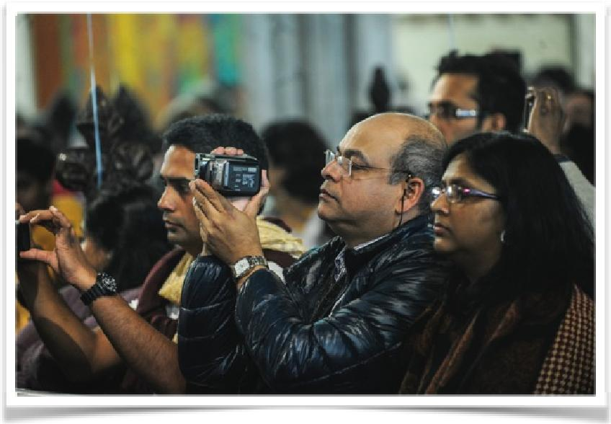

We had great press coverage - and in fact the radio stations - BBC Cambridge, Camb105, Star - all covered us on several occasions. Here is the press link for the Great St Mary’s launch on May 11th link to the video and images: http://www.cycleofsongs.com/news/#video-vela-vela-at-cycle-of-songs-launch-at-great-st-marys-church

The audience and feedback were very positive indeed as you can read in the link here from the Cambridge News. In addition to the work with Choirs and recruiting individual singers, there were significant partnerships in development with two-way exchange of ideas and value added by the coming together of Cycle of Songs with Great St Mary’s, and then Cycle of Songs working in partnership with The Fitzwilliam Museum. On 16th May, The Fitzwilliam Museum showcased the artistic talent of Cycle of Songs at their ‘Museums at Night’ event, with a concert by members of “The Spinney School Singers” opening the entertainment, followed by unique pieces performed by Hannah Brock and Alex Cook, also choir pieces performed by “ReSound” and by “Chela, the Georgian Choir” ending with the postdoc swing music of the Searle Street Band rounding off the evening. There is the blog link here http://www.cycleofsongs.com/news/#blog-cycle-of-songs-at-the-fitzwilliam-museum-for-museums-at-night

As we talked further with The Fitzwilliam Museum about a project with school choirs running alongside our Cycle of Songs Choir event for 7th July, Helen started to work closely with Joe Shaw and Tizzy Faller at CaMEO – the Cambridge University Music Faculty Education Outreach programme, - who were also interested in working with the same range of primary school choirs Helen had already contacted, so they agreed to join forces and to provide Cycle of Songs with invaluable infrastructure help.

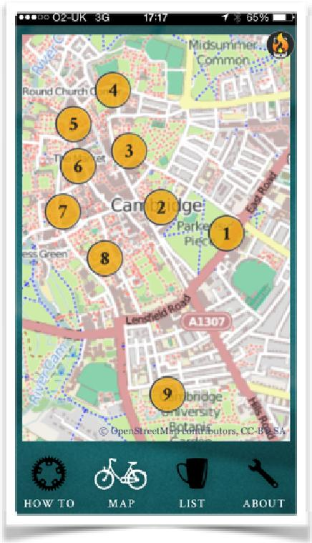
May was a busy month as clearly we were also building the prototype of the app. This was an opportunity for the Pilot team to liaise with Calvium and to test the geo-location of the content and to test walk the route with the whole Historyworks team too.

This was being built in tandem to the compositions and creation of the pieces so we were running the project in parallel with the creation of the work on the ground with Helen and her team.The key timeline for us all was to have the recordings and content of the pieces ready by early July to test the app and for it to get prior approval on the app store. Here is a blog that Calvium wrote about the app development: http://www.cycleofsongs.com/news/#blog-post-calvium

May saw the choirs learning the pieces. They were selected and match-made by Helen and her team - Jon Calver created the audio guides from the composers and posted those on the website so that the individual choirs and their leaders could access and learn the relevant parts.

This was a very creative and expedient mechanism of delivery. The scores were able to be downloaded and the sections we accessible via sound cloud for the choir leaders to then utilise and teach their respective singers.

Here are the resources that the choirs could access:
http://www.cycleofsongs.com/resources/

In tandem to this - our graphic designer team led by Mat Lazenby at Lazenby Brown (with whom Pilot Theatre had worked for over 5 years) was creating the branding and materials for the app to be delivered to Calvium.

In addition our press and PR was also getting radio and press coverage for the Pilot and HistoryWorks teams.
There were ways we could we could support and amplify press coverage, by providing illustrative blogs on our own NEWS stream at Cycle of Songs website here:
http://www.cycleofsongs.com/news/
And we have the satisfaction of the high hits on the website and the five minute dwell time, proving that the website offered deep engagement for the users who visited. There are many recordings and archives that Sam Johnson was able to put on the website for the project under Jon and Helen’s guidance - and this was a great boon for all the media outlets and acts as a lasting digital account and legacy of the project. Similarly the downloadable images for all press usage were all made available by Sam on the marketing resources area of the website – for example, Rowena Whitehead at BBC Radio Cambridgeshire:
http://www.cycleofsongs.com/news/#radio-rowena-whitehead-on-bbc-radio-cambridgeshire

June

The key activities in this month were getting the work signed-off with the composers/ poets to conclude the process of rehearsing and recording the nine pieces. The artists who were commissioned were :
Alex Cook, Composer and Performer
Andrea Cockerton, Composer
Dave Cohen, Writer and Comedian
Hannah Brock, Musician
Hollie McNish, Poet & Lyricist
Inja, Rapper and Poet
Karen Wimhurst, Composer
Kirsty Martin, Composer
Michael Berkeley, Composer
Michael Rosen, Poet
Peter Gregson, Composer
Rowena Whitehead, Composer

The full details can be found about their work and each of their names has a live link also to a page describing their motivations and experiences composing for the Cycle of Songs – see:
http://www.cycleofsongs.com/resources/composers_poets/

As part of our work we wanted to engage with the key ACE organisations in the city. So in addition to telling people about the Cycle of Songs and distributing our postcards inviting people to join us when we attended and performed at the Fitzwilliam Museum on May 16th – as part of the project we also invited the ‘pop-up’ choir to be safari style and arranged rehearsals at Kettle’s Yard, Cambridge Junction and the Music Faculty on West Road.

The idea for this was to introduce our choir and volunteers to these spaces. There was some resistance to this idea at first, especially from Rowena Whitehead because she was understandably concerned that we might lose members of the choir because a variety of locations might lead to a confusion about rehearsal venues, and might be difficult for those with access issues. It is possible we lost potential singers who did not like the idea of going to a different and/or unknown venue every time. But the website and the postcards clearly had the venue dates and times marked from the outset, and in fact many of the singers remarked on how much they enjoyed exploring new spaces and places.

An interesting show of hands from the 100 who came to the first rehearsal for the Cycle of Songs popup choir indicated that for more than 50% it was their first time in the house at Kettle’s Yard!

See the blog about the Kettle’s Yard Experience:
http://www.cycleofsongs.com/news/#blog-cycle-of-songs-rehearsal-at-kettles-yard

In addition to the choirs learning their pieces, the app being developed, the rehearsals at the various venues Marcus also commissioned a visual artist, Tess Ainley, from Cambridge to create a hand stitched mixed media map that we would use as a graphic for the app map.

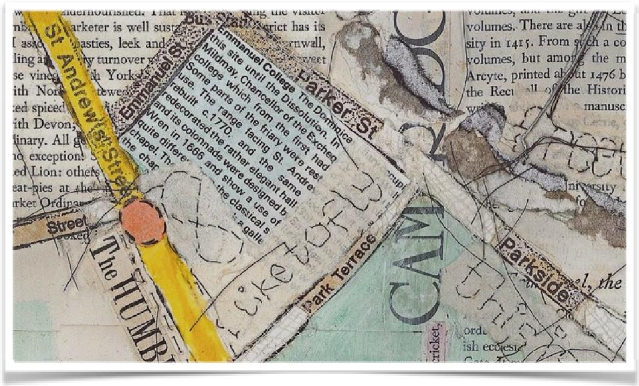

The combination of the organic and multilayered threaded work worked well with our threads of stories and connections, but provided an enriching contrasting legacy to the hi-tech nature of the app. The story for this time in the project

So we rehearsed at the three aforementioned venues and were able to document this for the final archive flickr stream to share with all those involved with the project. Henri Ward agreed to be our Stills Photographer for documenting these events, and he covered 11th May, all the public events in June, also the 5th and 7th July, getting to know all the participants in the Cycle of Songs and their getting used to being captured in photography. In addition, at every event Henri captured some sequences of film footage, because Helen had made a commitment to Henri to also give him an internship and mentoring to involve him in the final film using kit provided by Historyworks, purchased specially for this purpose as the project could not afford to hire equipment for all of these events. Also, Helen devised a method to make the photography and filming at the rehearsals meaningful, by inviting singers and musicians to perform at every venue as a welcome to the Cycle of Songs ‘popup’ singers and to give both the performers and the audience a transformative experience.
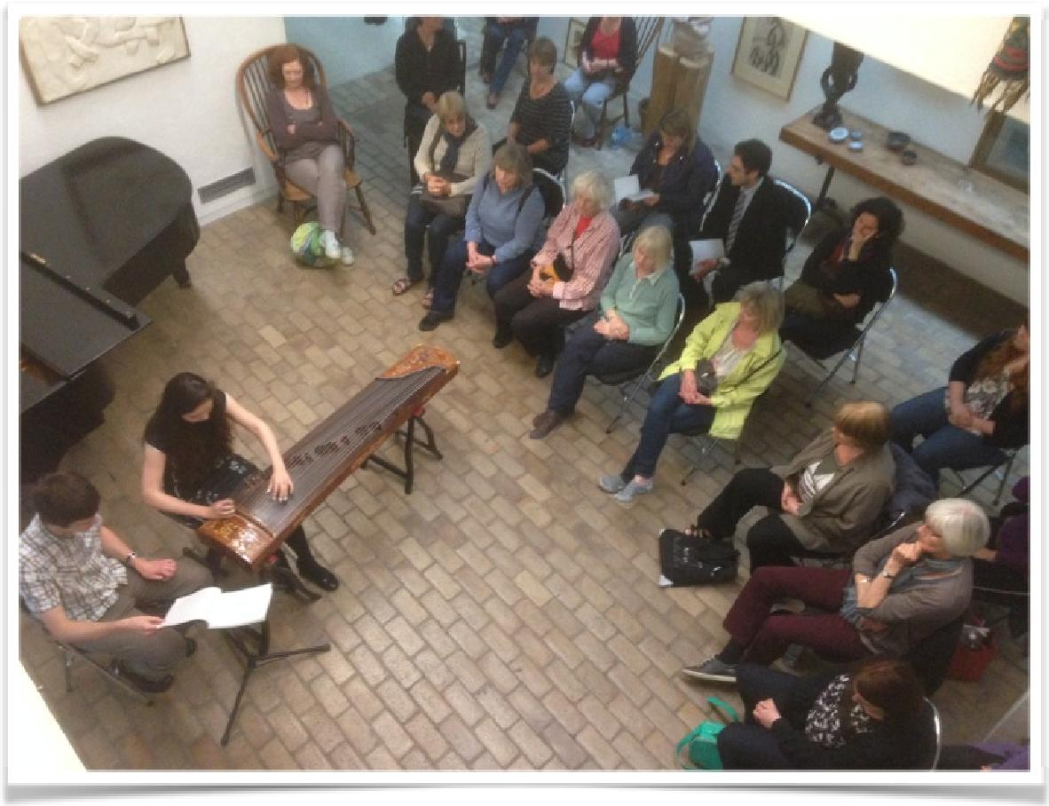

This became a key and important plank of the project and very fruitful as the choir came together to not only learn the “Why We Ride” anthem and the “Allez Velos” song to welcome the cyclists on the 7th July, but also to hear some sections of performances from the other pieces. We had Alex Cook and Hannah Brock rehearse and then perform at Kettle’s Yard, filming their endeavours, an enriching experience for all involved, and you can their performance on the Cycle of Songs showcase film here: www.cycleofsongs.com/film/
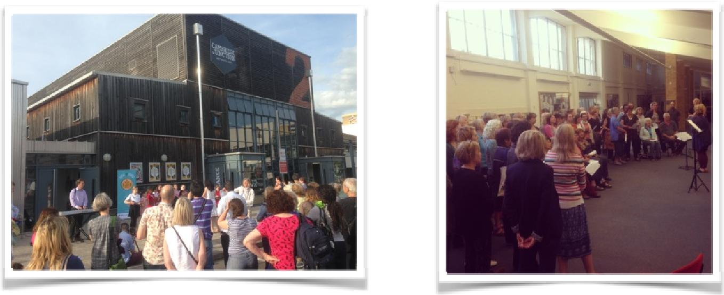

The rehearsals continued at Cambridge Junction and The Music faculty as we prepared for the flashmob event on June 21st at the Guildhall and Market place in Cambridge, an event designed to surprise and entertain the public.

All the time alongside this the choirs for the app recordings were also rehearsing separately with their own choir leaders in preparation for the recording and filming that would take place. This was a very intensive time of planning and coaching, with Helen Weinstein, Rowena Whitehead and Sam Johnson working extreme hours to bring all the elements to fruition. None of this part of the project would have been possible without the quality of recording experience and production that we were able to offer the composers, poets, and choirs.

Jon Calver is highly experienced in turning round audio and video content to extremely tight deadlines - so although short timescales were not overly concerning on that score - the intended involvement of school, college and community choirs and composers - all with other commitments - meant rehearsal time was going to be minimal and the window of opportunity for recording tight. As a result Helen and Jon often found themselves managing the artistic ambition of the composers in order to provide the performers with enough time to rehearse. All this put huge pressure on the timeline of deliverables.
The line up for the recorded works was finalized thus:
1: Reality Checkpoint – Parker’s Piece – by Andrea Cockerton with the Dowsing Sound Collective
2: Why we Ride – a reversioning of a project by Hollie McNish by Rowena Whitehead and Kirsty Martin - the CoS anthem – with a choir formed of participants who volunteered from across the city and beyond
3: Infinity by Peter Gregson with The Infinity Choir specially formed to sing this very tricky work
4: Freedom by Inja involving the Revelation Rock Gospel Choir performing together with Sing! Organized by Helen and Tizzy at the Romsey Mill Community Centre. However, this work was only brought to fruition by the diligence of Rowena Whitehead working with Inja and the choir leaders to score for him the choir accompaniment, because the rapper did not have this skillset himself, an important learning journey for all that had a wonderful outcome!
5: Unsung Women by Kirsty Martin with Women of Note was also very difficult piece and a challenge for the choir who were coached by Kirsty who travelled up from Brighton on 3 occasions so that they could learn the piece successfully, and requested to Jon and Helen to have an extension up to 2nd July to re record their piece for the app
6: Build this House by Michael Berkeley with King’s College Choristers performed in situ with Milton Road School Primary Choir, with leaders Stephen Cleobury and Anna-Louise Lawrence – with the Choristers teaching the primary singers the piece by singing out their lines which proved to be a very enjoyable and efficient way to learn a new piece to sing together – all the children came over to Great St Mary’s for play time and refreshments provided by Cycle of Songs afterwards
7: Hobson’s Horses, as a warm-up round for primary singers written by Dave Cohen, and a more complex piece for the app called Hooray for Hobson, with music by Karen Wimhurst and lyrics by Dave Cohen, sung by many primary school choirs involving almost 2,000 children in all by the end of the project.
8: The Listening Lions written and performed by Michael Rosen recorded in London with fx treatment for the app by Jon Calver
9: To Seek a Dream by Alex Cook with Hannah Brock and the voices of the Chapel Choir of Selwyn College. Alex and Hannah were the youngest Artists contracted to compose for the project, with Helen approaching Hannah in January to discuss her performing a piece on her Chinese Harp inspired by the lyrics by Xu Zhimo, and because only one of the Aldeburgh Young Musicians, Alex Cook has consistently composed for her instrument, it was fitting that this very talented young composer, now a first year music degree student at Cambridge himself, was commissioned to compose “To Seek a Dream” for strings & voices.

The musicians for the first piece to be laid down, “Reality Checkpoint”, were recorded on May 30th at the Zoo Audio studio of Andy Cross based in Milton – (the involvement of Andy was to prove a serendipidous newly discovered collaborator as events unfolded over the next two weeks) and on June 1st the mobile sound studio truck of Peal Sound came to record The Dowsing Sound Collective performing “Reality Checkpoint” during their regular rehearsal at St Faiths School.

The week of 9th June was a crucial week with deadlines fast approaching for the test version of the app to be submitted to Apple for approval.

A dress rehearsal for Infinity was filmed at Emmanuel College on 12th whilst the choir for Inja’s Freedom track was recorded at Romsey Mill that same evening.

Friday June 13th was a big day whereby Helen had organized for filming and recording occurring across five sites in some cases simultaneously: The Music Faculty (To Seek a Dream), King’s College Chapel (To Build This House), Great St Mary’s Church (Hooray for Hobson) , St Johns College Archive (Inja viewing documents and performing reflections on his rap) and Emannuel College Chapel (Peter Gregson’s Infinity). This was efficient, especially because Historyworks hired two cameramen and batches of lights, and in addition Helen hired a special camera for low light conditions at an additional cost of £350 to the camera operators at £400 each so that she could direct this camera to capture beautiful shots of expressive faces in places with reduced natural light, specifically King’s Chapel, Great St Mary’s, St John’s Library, and Emmanuel Chapel – all filmed using the same camera for a day rate.

The next few days were spent furiously mixing and mastering these recordings in order to have test app available for Calvium ( the app creation company who had been contracted to make the geolocated software) to submit to Apple for approval.
For such a small budget for the recording and filming, it was incumbent for Historyworks to be efficient in this element of the project. However, because of the death of Jon’s father and our Historyworks team member Ross (cameraman/editor) also suffering a bereavement because his grandmother died overnight on our big filming date; and because a couple of the choirs needed an extra rehearsal and recording session after the submission of the draft app, it was necessary to bring in additional sound engineers and film editors at short notice for cover, so Historyworks was not actually able to break even on this element of the project, but what was most important was to develop excellent working relationships in Cambridge, and to offer top quality productions so that this investment might bring in further production and partnership work for Historyworks in Cambridge in the future.

So all recordings took place within a five week window - and the HistoryWorks team worked hard and got all the pieces recorded from the various sessions with long days and nights in studio to finesse the edits. One of the challenges we had was that with a couple of the pieces where the choirs had not had sufficient time to learn such complex pieces to the quality necessary for the album app, we had to record them verse by verse, and carefully clip the pieces together.

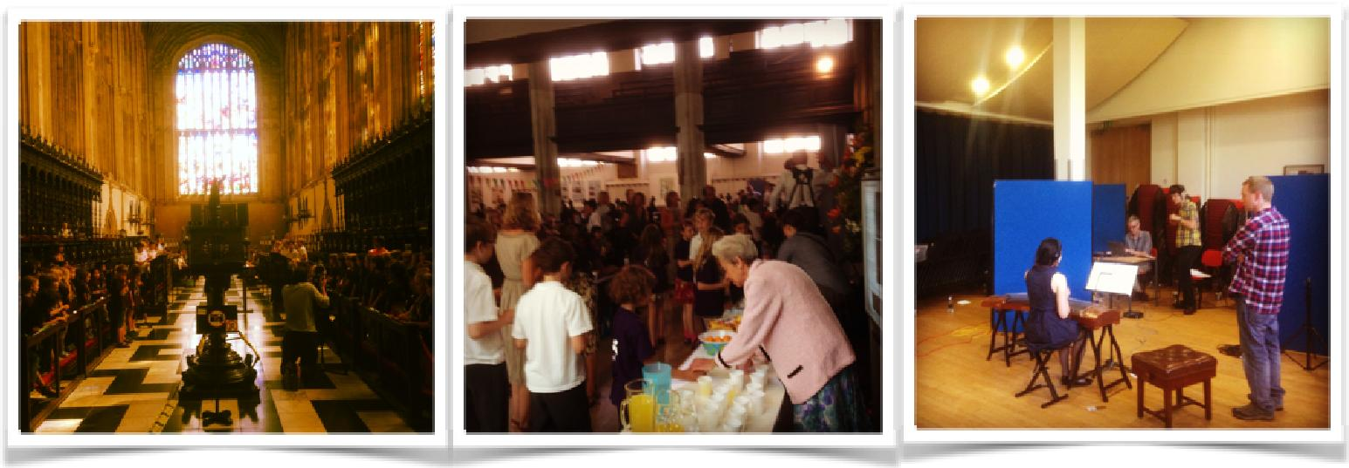

The flashmob event took place at the Guildhall on Saturday 21st June, and Ben Pugh kindly came to join us from Pilot Theatre in York, to help with managing expectations with the Guildhall Staff and also the Market traders. Joe Shaw from CaMEO was running a brass band project adjacent to our rehearsal in the Guildhall, and this made for a creative and vibrant atmosphere. Most of the 150 adult singers who turned up on the 21st of June at the Guildhall were already members of the Cycle of Songs popup choir and their friends and family, but in addition we also had about 30 members of the young people from “Cambridge Ten Sing” and about 20 singers from primary school choir, “The Spinney Singers” – but because of the assets available ahead on the website, those gathered together were taught to sing together in less than an hour - thanks to the composers of “Why We Ride” - Rowena and Kirsty –who worked dynamically and tirelessly to support and coach and direct the huge choir. There was some sticker action and moves choreographed by Marcus Romer to surprise and entertain those in the market with the two impromptu performances outside in the blistering heat.

Here is the report in the Cambridge News with more photos

& the blog from HistoryWorks: http://www.cycleofsongs.com/news/#blog-21st-june-flash-mob

Whilst all this progressing the uploads had to happen for the app on June 19th to keep to our launch timeline - to allow for the two week sign off period by Apple to approve the app

So again Sam Johnson and Helen Weinstein checked all the material, with Sam taking the lead on preparing the photos and lyrics and history stories, checking and rechecking so that all the assets and recordings and text were uploaded into the specially built app trail designer programme created for us by Calvium - where we could delineate the geo location areas for each piece.

We wanted to ensure that from an end user and audience perspective they would always be ‘in sound’ in the city centre. So Marcus who was working closely with Calvium on the app, developed created the areas to allow this to happen using a block system shown below:
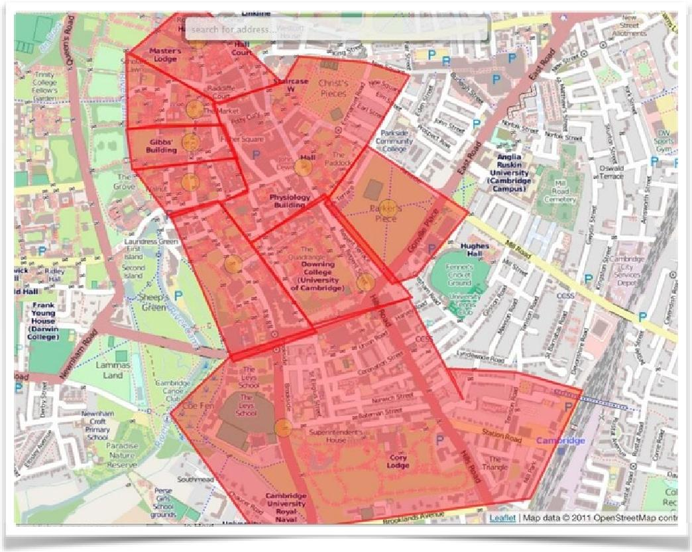

Also we wanted visitors from abroad - who could have their data roaming turned off to still experience the app without incurring data charges - again keeping it free - so a bespoke map for the app was built to enable this to happen.

The mixes for some of the songs were going to be be re-edited for an app update as per our original plan so these were rehearsed and undertaken as additional recordings at the Music Faculty Recital Rooms, led by Helen Weinstein with sound recordist Andy Cross on 1st and 2nd July

July

The film was completed in the lull at the very beginning of July, because although we had many sequences prepared, it was not until we had all the recordings top notch quality, that Jon and Helen could listen through and do a final cut of the soundtrack. Helen’s concept for the film was to use a yellow bicycle as a metaphor for the journey of the project and to show a snapshot of Cambridge via a synopsis of the 9 pieces, through animation giving the message that it was a fun and quirky film, showing the outside of the iconic places in Cambridge and then bringing people into those places to hear some remarkable new compositions, suitable for viewing on a phone screen. To fit the remit of the app company which constrained our space, all the audio pieces were commissioned by Helen to be no longer than 4 minutes, and because a couple of pieces were shorter, we could give ourselves 5 minutes for the film, instead of the original 4 minutes proposed . The film has been widely praised and enjoyed, disseminated on social media and screened in choir gatherings and school assembly halls, working very well as a taster of the 9 pieces and a visual tour of the entire TdeF route in Cambridge.

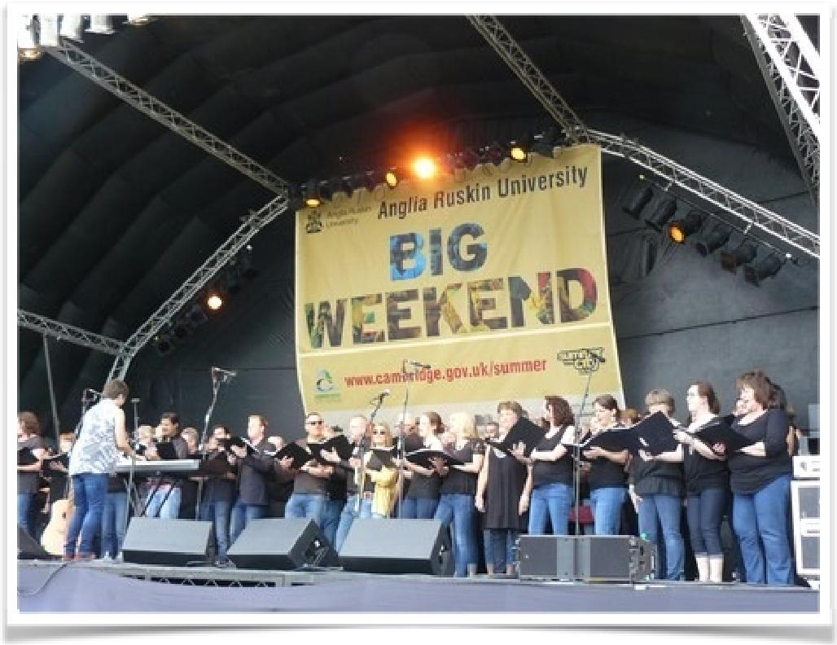

The app was launched on the 5th of July - at the start of the actual TDF in Yorkshire - this coincided with us having a marquee at the Big weekend on Parker’s Piece as well as the Dowsing Sound Collective choir and band of 120 performing on the main stage in the afternoon. This coming together would not have been possible without the detailed work of Frances Alderton at the Council working early on to negotiate for high profile performing spaces for the Cycle of Songs and we were very grateful for this exposure, and to Dowsing for performing on the Main Stage, and to Rowena for leading the Cycle of Songs Choir too.

We had 10,000 app map leaflets printed with download instructions and the guide map of the route on the inside.

We distributed by hand across the whole weekend about 4,500 leaflets. Whilst Dowsing performed on stage, Helen and Marcus and Jon engaged those sitting on the grass listening and gave out the app maps. We also had Sam and Ben in the Marquee all afternoon, sharing the app with members of the public and showcasing the film and the website assets at a row of PCs within the Marquee.

We placed a further app maps – about 1,000 along the route and at the TIC and at shops and venues along our map route.

We gave 1,500 at our partner venues and the remaining were hand delivered out by Helen and her team on July 7th and post the actual event, including Helen visiting the schools involved in the singing and speaking at choir concerts and assemblies, showcasing and explaining the app, in which she gave out 2,000 app map leaflets for these participating primary students to take home and share with their families at the end of their school events in mid-July.

We have some archived and spare - about 1,000 remaining for further distribution in time.

Here is the HistoryWorks Blog about the Big Weekend: http://www.cycleofsongs.com/news/#blog-parkers-piece-and-sing-swim-saturday-5th-july-2014

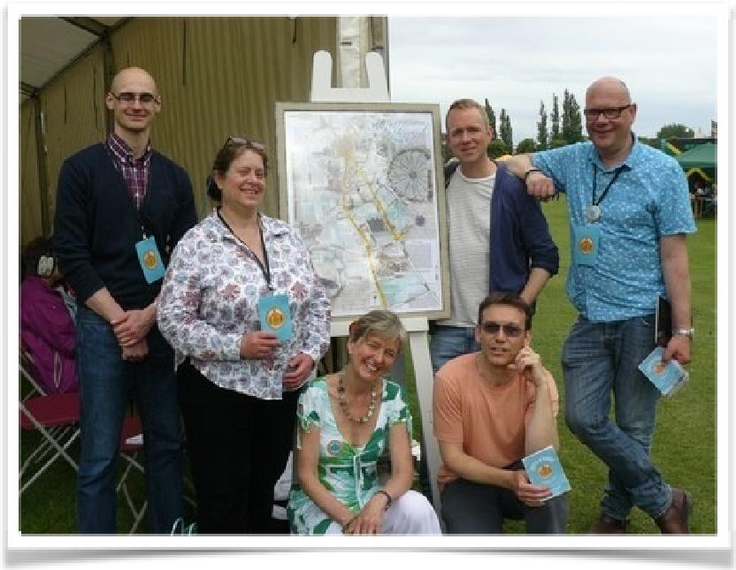

The Pilot and HistoryWorks team with the print of Tess Ainley’s artwork outside the marquee at the Big Weekend. Sam, Helen, Ben , Marcus (standing) Rowena and Jon (kneeling)

A sister project we also helped to support was Rowena Whitehead’s ‘Sing and Swim’ event on Jesus Green at the Lido. This was important because so many of the primary school children and their families from Milton Road Primary School, St Lukes and Arbury were involved. It was an important venue where families were joined together and hanging out in a relaxed environment, suitable for giving out the app map, showing families how it worked on our phones, and really engaging and talking about the project in detail with the families of the primary singers involved. Therefore we were happy to be able to support and help with leaflet distribution for this event.

On Sunday July 6th Helen Weinstein distributed our app leaflets at the start of the race in York, and Marcus Romer delivered leaflets on Parker’s Piece and the route of the race in preparation for the big day on July 7th.

Race Day

On this date, we had long prepared for the “Song Fest” on the steps of The Fitzwilliam Museum – which was only possible after considerable planning and support from the teams at the Fitzwilliam Museum and with our partners CaMEO (the Music Faculty Education Outreach) who not only helped Helen in particular with the relationship building and detailed planning for the primary school involvement, but also donated in kind by paying for the buses for the children to attend from schools beyond walking distance, for Milton Village Primary and for the children who are involved with the youth music outfit called “Shout Aloud!” . With the facilitation of The Fitzwilliam Museum we could ease the concern of the schools and our Cycle of Songs Choir, to avoid the public access gates on Trumpington Street, and instead we were able to plan to access the site via Peterhouse College and the gardens behind the Fitz itself. The education team from the Museum were amazing and we had the support from the SMT for the whole operation which enabled us to assemble 200 school children and their teachers, our Cycle of Songs ‘pop up’ choir of 100, and our artist guests and helper teams who had volunteered to make this work.
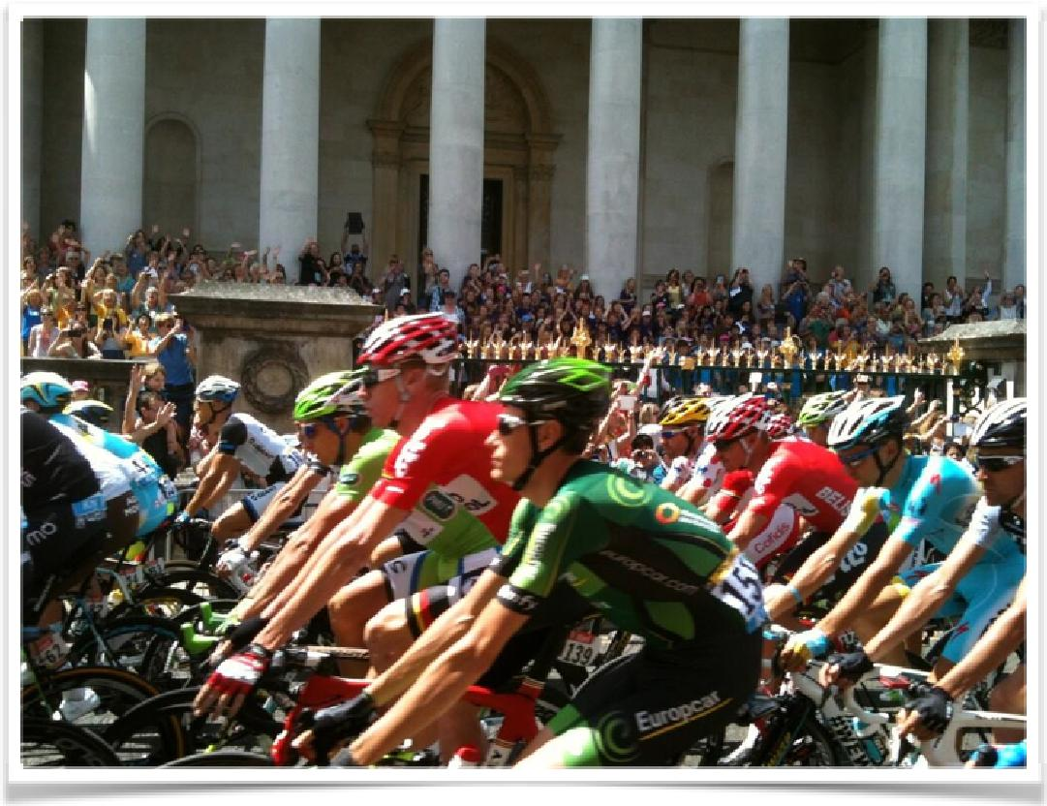

The partnership that Helen Weinstein had brokered with Joe Shaw at CaMEO was essential, and their team assisted with the PA and transport and snacks and water bottles for all 200 primary singers. The important thing about this partnership was to make it a real partnership and viable beyond the Cycle of Songs, with the parties committed to offering another opportunity for a ‘scratch choir’ event this Autumn, where Historyworks will support CaMEO in return for their commitment to helping us so coherently on 7th July, by inviting the Cycle of Songs singers to join in this next event called “Your Song” for a performance on 29th October, and for this Autumn season of rehearsals and performance delivering audio recordings and photography services of the same quality for sharing on websites as enjoyed by all the participants in Cycle of Songs. See
http://www.cycleofsongs.com/news/#your-song-celebration-of-community-singing

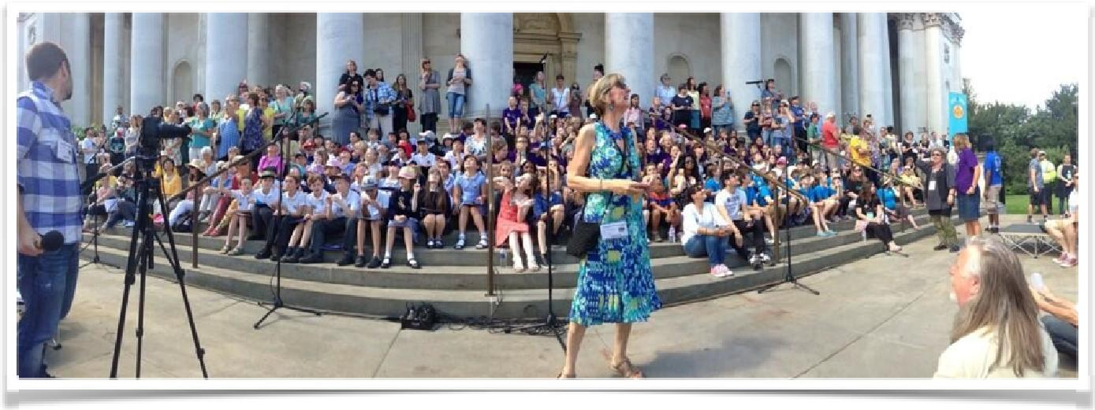

The primary school singers after their orientation with The Fitzwilliam Education staff and their snacks provided by CaMEO were the first to rehearse and it was an impressive sight to see them all in their groups singing their hearts out in the red gallery 3 of The Fitzwilliam Museum. Meantime, the Cycle of Songs Choir assembled on the steps, entertained by the Searle Street Band, the postdoc signature band who had already played at the launch event on 31st March, and were again entertaining our singers and the crowds in the street with their swing numbers. Once everyone was in place, and Rowena and Kirsty were ready to direct from the front, the Cycle of Songs really came together at this event, as we sang on the steps prior, during and after the cyclists had passed the museum.

Here is the Blog about the event :
http://www.cycleofsongs.com/news/#blog-parkers-piece-and-sing-swim-saturday-5th-july-2014

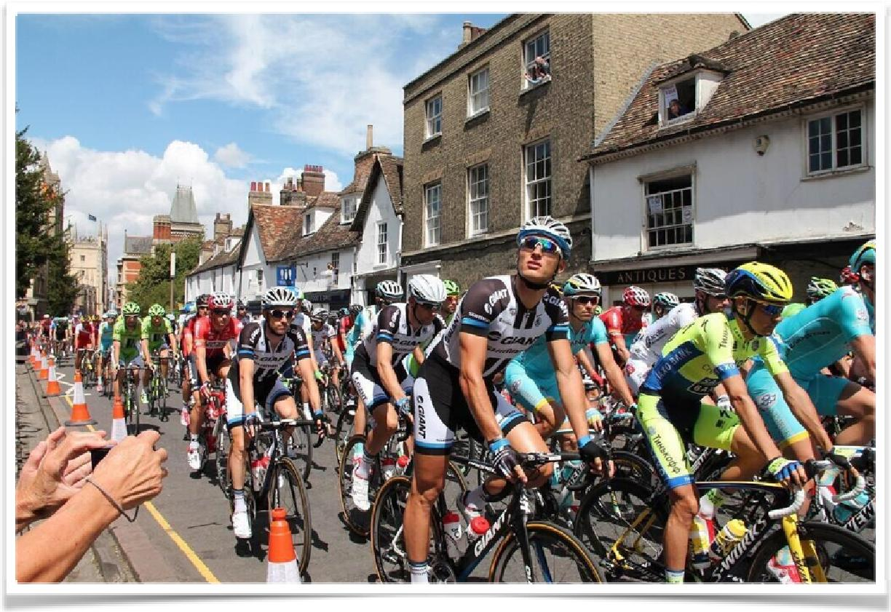

The winner of the stage, Marc Kittel, is photographed here looking up in bemusement, and seems to notice our singing ‘Allez les Velos’ in French too…

The decision to not bring the Cycle of Songs to Parker’s Piece to the start and the village had been a difficult one- because we wanted to ensure the security of our choirs and schools - we seemed to miss out on the media coverage ( half a second’s worth of footage on ITV ) which was a shame - as we had made it clear that this was where we would be for about two months and we had an impressive and distinctive group covering the entire steps of The Fitzwilliam Museum.
But we were not alone in complaining about lack of aerial coverage in Cambridge during the start.

However the coverage from 105FM and BBC Cambridgeshire was consistently attentive throughout the duration of the project, including the 7th July, but once the Chief Press Reporter, Chris Elliott was on holiday the personal connection with Helen Weinstein was absent and there was no coverage. The PR firm engaged by Marcus Romer to place coverage for local and national stories told us he found the Yorkshire splash hard to compete with, although he did place a piece about Marcus Romer with a double-page spread in the Yorkshire Post on the 5th July: http://www.cycleofsongs.com/news/#yorkshire-post-pump-up-the-volume

However, to make up for this gap of press coverage in Cambridge on 7th July, we have subsequently followed up with Press outlets. Helen Weinstein has visited schools to showcase the Cycle of Songs film and the app map, and distributed to the Music Faculty and the Colleges and all the Schools with leaflet distribution and press coverage post the event which has been immensely useful. Helen has used the visits to Schools to increase dissemination in their newsletters and websites, and as a hook for further coverage at Cambridge News: http://www.cycleofsongs.com/news/#cambridge-news-pupils-at-milton-road-primary-school-in-cambridge-sing-their-hearts-out-for-cycle-of-songs-project-for-tour-de-france

Although the contract for employing Helen Weinstein and Sam Johnson ended on 7th July, Pilot Theatre agreed to use the evaluation funding of £500 for Sam Johnson to work significant further hours in July to provide the wrap-up work and requests for evaluations. In order to trade favours to gain 100 survey monkeys we worked hard to do good wrap up, namely: to update and complete the Cycle of Songs website especially the NEWS blog, to tag and upload the pictures capturing the launch of CoS with hundreds of photographs so that the flickr for Cycle of Songs would include those taken 5th to 7th July, to provide support for the schools visits to distribute the 2,000 app maps, and to finish the photograph tagging which was immense from the additions from schools as well as our own volunteer photographers, and to send out the thank yous to all involved, and then to ask for evaluative feedback with the survey monkey, sending out reminders to participate in the app and to join the next singing opportunity with “Your Song” at the Music faculty this Autumn, and a “One Song, One Gig” event organized by Cambridge Junction for 9th August, keeping the Cycle of Songs community vibrant and requesting the all important feedback needed to complete our reporting for the Commissioning panel. This additional support for Helen was super useful and completing the film and photography assets allowed us to then write website pages for publication at Cambridge City Council, Visit Cambridge, and to assist with photographs and film to have website pages uploaded at CaMEO, Michael Berkeley’s website, the Cambridge Museum Blog, and to draft content which we hope will be used to push out the app awareness and useage via the development and Alumnae pages at Emmanuel College, St John’s College, King’s College, Selwyn College, and the Cambridgeshire Collection at the City Library – and a forthcoming project planned with Michael Rosen later this next academic year will be another opportunity for press coverage and to introduce the app to further new users.

Here is a blog about the visit to the Spinney Primary School:
http://www.cycleofsongs.com/news/#blog-spinney-singers-receive-certificates-of-achievement
And the wrap-up concert and app map distribution at Milton Road Primary School:
http://www.cycleofsongs.com/news/#blog-milton-road-primary-school-visit-22nd-july-2014

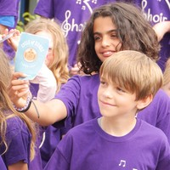

4: Stats and Numbers of Participants in Cycle of Songs – public launch on 11th May to end date of capturing stats of 8th August 2014

4a ACTIVE PARTICIPANTS NUMBERS
The number of participants in the Cycle of Songs Choir was 130, and the number of participants at the Cycle of Songs Launch on 11th May at Great St Mary’s was about 350. Importantly, the additional number of participants involved in June and July via Cycle of Songs rehearsals and recordings, events and performances came to 1,098 ( as numbered by data held by the HistoryWorks team). In addition to these musicians, Helen also did the followon work and developed relationships with primary school choirs that was not detailed in the original plan for Cycle of Songs, but became a very welcome additional aspect of our reach for the project, involving all in all close on 2,000 singers from a range of primary schools across Cambridge. There are plans to embed this Artistic experience in a legacy project with schools and Michael Rosen’s lion poem at The Fitzwilliam Museum, including a visit from Rosen performing for schools.

4b FILM AND AUDIO AND WEBSITE STATS
The plays from the Cycle of Songs short film on Vimeo and via the app have been high, and the feedback very rewarding, with over two thousand plays since the film was released for the Big Weekend on 5th July, and the interest not diminishing since the end of the project.

Interestingly, the biggest success for project has probably been the audioboo plays for the recordings of the pieces made by Historyworks, with 11,766 plays in total between 8th May and 8th August. This compares to 358 unique downloads for the app by 8th August, 277 for Apple/iOS and 81 for Google Android.

However, these figures for the app and the film, are far outshone by the huge engagement that was demonstrated by the number of visits to the Cycle of Songs bespoke website with 116,200 visits between the launch week when the site went live on 8th May and the date when we last gathered stats on 8th August. These amount to 62,651 page views with 37,159 unique page views; and 3,471 downloads and 1,205 unique downloads. The average dwell time for a website is astonishing and a testament to the rich and diverting content, with an average dwell time per 116,200 visits of close on five minutes.

Website Dwelltime and High Useage: This is important learning for the potential way in which a project can have deep engagement for the school children, their teachers, the adult participants, the composers and poets, the agents and press – all praising the quality of content at http://www.cycleofsongs.com/

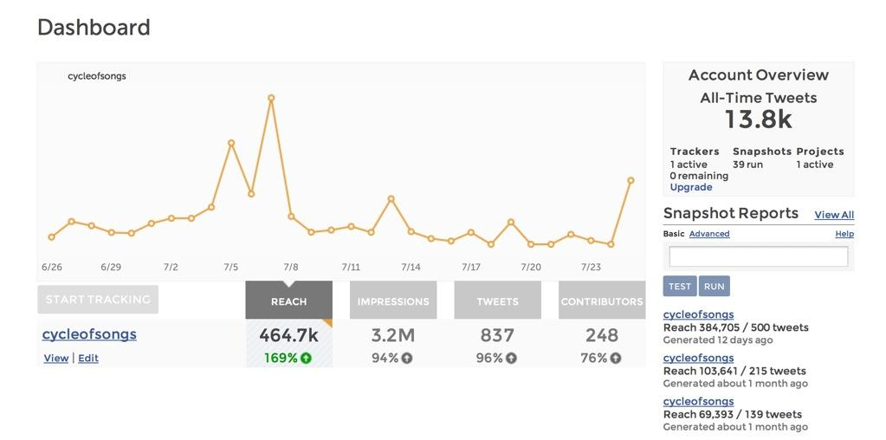

4.3 TWITTER STATS:
We have the Cycle of Songs twitter stats showing the potential reach for the whole project - as we monitored the #cycleofsongs hashtag from May to July – and the graph above shows the active participants with the numbers of tweets using the hashtag numbered as 837.

What is key to observe here are the spikes of activity on the Big weekend launch July 5th up to and including Race Day on July 7th and more recently when we have just had the report in the Cambridge News from the visit of Helen Weinstein to sing with Milton Road Primary Choir on 22nd July, all of which have striking spikes.
The stats for twitter indicate a potential very wide reach, especially because of the high numbers of followers to Marcus Romer @marcusromer, Pilot Theatre, @pilot_theatre, & Helen Weinstein @historyworkstv. It was also very helpful when we were retweeted or actively tweeted by the Museum partners, University faculty and College partners, and particularly the Cambridge City Council and the Tour de France twitter handles. However, amongst our participants of singers and musicians, we only had 12 active tweeters out of 1,098 involved. We reckon this is due to the age cohort of our participants and because their professional affiliations, many teachers and social workers, meant that the time and social constraints of work and family lifestyles, meant that they were not active tweeters. For reaching beyond our singers, and making networks of arts professionals aware of the project, especially beyond Cambridge, the #cycleofsongs twitter activity was however extremely useful.

4.4 APP STATS – 5th July to 8th August
The panel will wish for reflection on the App stats figures for download which amounted to 358 unique downloads for the app by 8th August, 277 for Apple/iOS and 81 for Google Android. Calvium’s Jo Reid has been very helpful in conversation with Helen Weinstein about the takeup of the app, suggesting to her ways of boosting downloads, because Helen was disappointed with these numbers considering thousands of leaflets were distributed over the Big Weekend, the crowds loved listening to the songs live, there was enthusiastic and fulsome coverage by local press especially Radio stations, and our participants loved the idea of recording and creating an app. 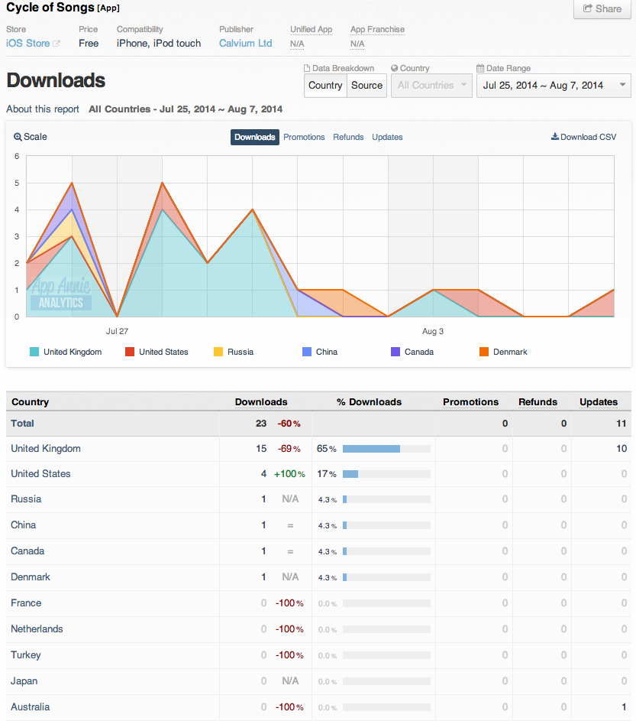
Marcus Romer has indicated that in his experience we need to be patient for a long tail of takeup. Jon Calver has suggested that the wifi was insufficiently strong at the Parker’s Piece to make it possible for the app to download efficiently in a festival situation. Also, Jon’s insight is that our main advocates for the project, the singing participants, particularly in the Cycle of Songs choir, were not users of smart phones. Indeed, the Cycle of Songs app was for many of the elder members of our choirs, the first time they had ever been shown an app on a phone. We therefore felt that our mission in showing the app was to be introducers and to be explaining this type of new technology to app novices. Our singers took up leaflets to share with family members and the next generation, and expressed great pride in contributing to the making of the app, whilst at the same time saying that they themselves were not confident and competent users of this technology!

It is interesting to reflect when you read the evaluations of the participants – whether they be the artists, the choir leaders, the media interns & volunteers, the singers, the schools – they all loved the project – they found the project fun and innovative – they thought the pieces were wonderful – they cherished coming together across generations to rehearse and learn to sing together and to perform to the public – they embraced the photography and filming and shared these elements with friends and family – and yet they did not take in big numbers to sharing this project via handheld devices – with only hundreds for the app takeup we therefore made up for it by having live events, the website and audio, film and photographs circulating to thousands.

Perhaps we have not yet found our app audience, because certainly the research students at Cambridge were those most app enthusiastic about showing and sharing to friends and colleagues and family, so this points to our making sure the 20/30 year olds who told us that they most enjoyed showing and sharing amazing works in the palms of their hands can easily find the Cycle of Songs through browsing iTunes. Jo Reid at Calvium has therefore recommended that we can all help longterm by liking the app on iTunes, and having our colleagues and family members favouriting and reviewing the app so that it goes up the ranking tables on iTunes in order that residents and tourists will find it. In addition, Helen Weinstein has given out the app leaflet to the 2,000 primary school children who were involved in the expectation that over this year they may download and listen again with friends and family. Further, Helen Weinstein has given out the app maps at Cambridge public history events and walks and led a Cycle of Songs team of Historyworks interns on King’s Parade for the 13th September Open Heritage Day, showing residents and tourists the app and encouraging them to download it. This #OHD14 demonstration methodology was successful for an audience that was wanting an Arts and Heritage experience in the palm of their hands whilst walking the streets and exploring the heritage of Cambridge because interested takeup and active downloading on King’s Parade was intense for this event.

4:5 WEBPAGE PRESENCE IN CAMBRIDGE
In addition to circulating the knowledge about the app, we have also published webpages introducing the Cycle of Songs app subsequent to the end of the project in a variety of locations. These have been written and submitted for the City Council website and for the Tour de France and Visit Cambridge websites. It would perhaps be useful for creating the longer tail useage of the app, if our panel partners could also be hosting Cycle of Songs webpages with links to the app on their sites for online visitors to The Fitzwilliam Museum, Kettles Yard, Cambridge Junction, Festival of Ideas online etc. Features have also been written for a number of Faculty Websites, including the Music Faculty’s CaMEO site, and Helen Weinstein is helping with a collage of photos celebrating the project and the app to be displayed in the foyer outside the West Road Concert Hall for the October term. In addition, several College websites involved with the Cycle of Songs (King’s, Emmanuel, St John’s, Selwyn) will introduce the project to students, staff and alumnae via features on their websites. Finally, our active history interns and heritage researchers at Doing History in Public.org located at CRASSH (Centre for Research in the Arts, Social Sciences & Humanities) have maintained a steady commitment to the project throughout and will induct new students to use the app this term. If members of the panel can also continue to help with links to forthcoming events, when appropriate, this will raise the profile of the app to increase downloads and hopefully provoke more reviews!

5:0 LEGACY EVENTS AND ACTIVITIES, FUTURE PARTNERSHIPS & FUNDING
The Cycle of Songs feedback has included expressions from the public at events that the funny songs have given an enhancement of Cambridge’s sense of place, an enjoyable experience which will not be forgotten by participants for generations to come, it mattered to celebrate the city’s cultural diversity, the activities aided community building, inspired and involved children and their families as participants or spectators, and for composers and choir singers and researchers the project enhanced the sense of belonging, with a welcoming feel at events of being free and open and accessible.

5:1 REPEAT PERFORMANCES SINCE 5TH/7TH JULY LAUNCH FOR CYCLE OF SONGS TRACKS
A significant measure of the success of Cycle of Songs is that there have been repeat performances of many of the newly commissioned pieces. Thus far, we have record of six items that have had scheduled repeat live performances within concert programmes. “Unsung Women” was performed to over a thousand gathered at the Hebden Bridge Choir Festival on 12th July conducted by Kirsty Martin and sung by the Cambridge group, “Women of Note”. Composer Andrea Cockerton’s “The Dowsing Sound Collective” performed “Reality Checkpoint” at the Apex Concert Hall in Bury on 13th July. “ReSound” performed “Why We Ride” for their 15th July concert in St Peter’s Church, Cambridge. “Hooray for Hobson” was performed by “Milton Road Primary Choir” in their 16th July end of year School Hall Concert for the entire school in the morning, and for parents and governors in the afternoon. On both occasions the Cycle of Songs film was watched as part of the Concert.

This Autumn 2014, the app piece called “Freedom” will be performed as part of the ‘Festival of Ideas’ in a concert on Wednesday 29th October at West Road Concert Hall, performed in an extended version by the community choir called “Sing!” which will be led by Inja, the rapper and composer, resulting directly from Inja’s introduction to the Music Faculty by the CoS project.

In addition, the CoS app piece called “Build This House” by the composer Michael Berkeley has been subsequently adapted by Michael, amplifying his CoS composition for childrens’ choirs to an extended version for SATB to be sung by the full choir at King’s. This adapted version will be performed in King’s Chapel, conducted by Stephen Cleobury, for Evensong at 5.30pm on Sunday 16th November when the music featured will be a prelude to the celebrations next year of the 500th Anniversary of the completion of the building of the Chapel. This offers an opportunity for a BBC tie-in and Historyworks has been talking to Michael’s agent about an “In Tune” on BBC Radio3.

The Historyworks team went to some trouble to find lyrics for “Build This House” that would fit well with the repertory of King’s Chapel. It is therefore very satisfying to witness these plans for repeat performances and recordings, and an ongoing relationship between Michael Berkeley and Stephen Cleobury as a direct result of CoS. Moreover, the invitation to primary singers to come and join King’s Choristers on future occasions means the transformative experience of singing in King’s Chapel can be extended this year to a wider group of children across the primary sector in Cambridge.

5:2 ONGOING PRESS INTEREST
It has been good for the Cycle of Songs local profile that there has been loyal coverage from radio presenters at BBC Radio Cambs and 105fm. Daniel Pitt, Arts Producer at the Cambridge Junction has a new slot on 105fm for an Arts programme, and kindly promoted CoS on Saturday 13th September, and you can find the podcast link to Life&Art here:
http://www.cycleofsongs.com/news/#105fm-arts-programme-features-cycle-of-songs-do-listen-to-the-podcast-by-daniel-pitt

BBC Cambs dedicated a programme to CoS on air on 7th August, when presenter Sue Dougan invited Helen Weinstein to join her for an hour for the “Chat Room’ to tell people about the free availability of the Cycle of Songs app and encourage them to go and use it for themselves this summer. “Why We Ride” and “Reality Checkpoint” were played on air. This was a very welcome follow-up after the previous BBC Cambs features with Rowena Whitehead on air at the start of the project for our launch on 11th May when she encouraged singers to join the CoS ‘popup’ choir, and then Inja talking about his piece “Freedom” in June and his wonderful visit to the archives, and crucially Marcus for the Big Weekend to promote the CoS stage performance & marquee. The BBC Cambs team intend to invite Andrea Cockerton on air soon to talk about “Reality Checkpoint”, and then to re invite Inja about his performing at West Road on the 29th October. So we have several next hooks for the diary for BBC Cambs to promote the Cos App.

Importantly, the learning from the relationship with local radio repeatedly returning to showcasing a project is that it is super helpful to the producers and presenters to have variety, and for Cycle of Songs we had nine audio mp3s tracks & local talent available to be on air.

5:3 ONGOING COMMUNITY SINGING EVENTS – SIGNIFICANT INCREASE IN CHOIR MEMBERSHIP

The Cycle of Songs attracted both those committed to singing in community choirs but also many who had not sung for many decades.

Even for seasoned singers, it was good to learn from them in feedback at events and in the evaluations that choirs really appreciated that Cycle of Songs gave singers in different groups the opportunity to sing to one another. Apparently this does not happen very often in Cambridge. So the model of our 11th May launch would do well to be replicated, when we asked the community choirs to perform two or three of their favourite pieces to others. This was repeated on 16th May and on 5th July with more than one group of musicians singing at the CoS events. The Music Faculty will be replicating this format by inviting community choirs to perform at the concert called “Your Song” on 29th October.

In the aftermath of the 7th July, the Cycle of Songs gmail has been used to ask for evaluative feedback but also has shared links to photographs and invitations for further singing opportunities. This has been welcomed by the singers, and carries the message that the commitment to supporting them in their singing experience did not end abruptly on 7th July. For example, musicians from CoS took up the invite from Cambridge Junction to join in the “One Day, One Song, One Gig” event on 9th August in such numbers that the event was oversubscribed. Similarly, Rowena Whitehead has recently had a very keen turn out from CoS participants to her “Resonant Song Workshop” on 28th September.

It has been great to hear from some of the choirs that they have a very large increase in members this autumn, with CoS singers joining community choirs. For example, “Sing!” has increased their membership by over twenty new singers this autumn, many joining after their CoS experience this summer.

There is one choir that is newly formed in Cambridge as a ‘scratch choir’, partly inspired by the Cos ‘popup’ choir, and it is organized by CaMEO, the Cambridge University Music Education Outreach team. CaMEO aims to bring together singers from the city beyond the University to be joining with those at University institutions, faculties, colleges who might not yet sing with others. The CoS ‘popup’ songsters were invited to become the bedrock of singers for this new choir, and rehearsals for “Zimbe” commenced on September 23rd. This choir will come together with other community choirs associated with CoS for a concert at West Road on 29th October, see:
http://www.cycleofsongs.com/news/#your-song-celebration-of-community-singing

5:4 DEVELOPING RELATIONSHIPS AND PARTNERSHIPS FROM THE WORK ON THE CYCLE OF SONGS PROJECT

Resulting from the relationship of CoS and Kettle’s Yard, the new singing project funded by the Zoology Department, led by Rowena Whitehead, is now partnering with the Education Officer, Karen Thomas at Kettle’s Yard, where the project will be based to co-create the artworks for a ‘scratch choir’. The singers will co-create new works inspired by objects and paintings within the collection of the University of Cambridge Museums, with a shipping and whale-based theme. The artworks will be performed as a perambulating song cycle, with the singers invited from “ReSound” and “Cycle of Songs” participants.

The rapper, Inja, has been introduced to the Music Faculty and to St John’s Archive facilitated by CoS and plans are in progress at both organizations to work with Inja. For example, Inja will be speaking and performing at the Music Faculty event on ‘Hip Hop’ as part of the Festival of Ideas this October, in addition to performing “Freedom” at the 29th October Concert.

The Great St Mary’s HLF project leader, Rosie Sharkey, has given considerable support to CoS, helping host choirs on three occasions. In return, Helen Weinstein’s history research students from CoS have gone on to support Great St Mary’s for various history research tasks for their new heritage interpretation projects. In addition, for the Elizabethan Pageant on 13th September to mark Cambridge’s Open Heritage Day, Historyworks helped out by capturing the event on film and making a flickr stream and a short film for GSM showcasing their event. It has been satisfying to have the history research students and interns be handed over to support another local heritage project after their experience of helping research and create online resources for CoS.

Stephen Cleobury at King’s has kept in close contact with Helen Weinstein, and asked for her guidance as Creative Director of the project to help further develop the artistic relationship with Michael Berkeley and facilitate the relationships with primary schools. This has resulted in the developed score for “Build This House” for King’s Choir, and discussions about how best to invite primary school choirs to have an experience of rehearsing and singing in King’s Chapel. For the primary singers who performed “Build This House” for the app recording, they told us that it was one of “the most scary” but at the same time “the most awesome” musical experience they had ever had. The students gave repeated feedback that it was not just the acoustic, but what made it so special was one group of children teaching another group of children, and the primary singers enjoying emulating the highly trained musicians that are the King’s choristers. The learning was an unforgetable experience for the primary children, many of whom had never experienced professional musicians. It is this peer to peer learning that needs now to be replicated, and the intention is to involve King’s choristers in the Lions project.

The Fitzwilliam Museum is kindly hosting a special event for primary schools in the Red Gallery on 5th December, which is called “The Listening Lions”. This event is designed to pilot a new project to take forward into 2015 as a legacy from Michael Rosen’s track, which will hopefully foster the embryonic relationship between the CoS primary school choirs with the choristers at King’s

Historyworks has organized for Michael Rosen to perform his CoS piece called “The Listening Lions” on Dec 5th and the children will learn a new song set to the words, and develop skills with Michael Rosen to create their own lyrics about the lions. Jon Calver will then make these items into audio files that can circulate to the schools and be used as starting points for teachers and students. CaMEO is helping fund and organize the event, with harder to reach schools involved on the day, participating in Helen Weinstein’s Creative Direction of an online resource with their contribution of a body percussion workshop!

Historyworks will make the education materials as online media products in partnership with the Fitz and CaMEO and under guidance from the Spinney School and Milton Road Primary Choirs who will lead on the project, with the aim being this time to share the “Listening Lions” as a pilot for a ‘Singing History and Storymaking” project across all of Cambridge’s primary schools.

Helen Weinstein will direct the camera and photography so that children can be the storytellers with Michael Rosen for two short films to help disseminate the launch of this project. One film will focus on lyric making and the singing of the new lion song. The other will focus on history telling and the Fitz foundation and building of the stone lions. It has been excellent to have such positive feedback from CoS because schools are wanting a legacy project that delivers the high quality of CoS as a creative experience for the children, which combines history and storytelling, objects and lyric writing, music and performance. The media products to disseminate the materials to schools has been kindly funded by a John Lewis Cambridge Music Fund Award to Historyworks.

5:5 DEVELOPING FUNDING FOR “SINGING HISTORY”
It is hoped that work on developing creative and richly textured cultural opportunities for children and young people will be a legacy of CoS. The partnerships between the CoS organizations are developing and it is planned that we will take forward this new project for national funding. The working title of the project is “Singing History” and Historyworks is scoping funding from the Historical Association for the object and image research and creation of teaching materials. CaMEO is scoping Music Hub funding to develop the body percussion and lyric workshops for 2015, and Historyworks has been offered further funding via the John Lewis National Music Fund. A concert date has been organized at West Road to launch the new project and for the first cohort to sing together in public on Sunday 8th March. It is expected that for 8th March the concert will be free for singers and their families and that Michael Rosen will perform poetry and the “Listening Lions” . In addition, other objects will have been researched and chosen and creatively rendered for performance live or in film for this event. It is hoped that panel members will have recommendations on how best to dovetail with other projects in Cambridge, particularly to develop the “Singing History and Storymaking” project to roll out from primary to secondary and beyond. The project will aim to be garnish significant publicity with the advocacy about the importance of creativity from Michael Rosen. The core value of the project will be to give young people a transformative creative experience and to connect them more viscerally to arts and heritage of Cambridge in the neighbourhoods where they live linked to the cultural assets in the centre of the city.

6: Learning from Evaluations

METHODOLOGY & FINDINGS OF EVALUATIONS
The methodology used for feedback included online survey monkey sent to partnership organizations and singing participants, vox pops recorded at events, phone interviews, focus group meetings with school children, group meetings with school heads, teachers, choir leaders.

The CoS project used a number of approaches for people to participate, signing up to be researchers for the project, singers in live performances, singers or musicians for recordings of pieces, volunteering to help at events, interning with the Historyworks production team to learn audio recording, filming, editing.

To help facilitate engagement and maintain the interest of participants, the project activities have been diverse in that although the rehearsals had to focus on learning particular pieces, the performance and recording sessions have exposed the singing participants to new cultural spaces and experiences.

The findings highlight an increased awareness of the cultural offer of Cambridge, an increased appreciation of community singing in Cambridge, and an increased understanding and appreciation of the heritage experience that Cambridge has to offer residents.

The evidence gathered shows that partnerships between the CoS project and the panel members from The Fitzwilliam, Kettle’s Yard, Cambridge Junction, University Public Engagement, and the City Council, all created opportunities for the public and participants to engage with the project, and thereby increased the awareness of artistic activity in the city, and were voiced as increasing a sense of wellbeing or pride about their achievements and their city.

6: Learning from Evaluations with Schools: Children & Teachers

7: Findings from Evaluations with Researchers, Artists & Singing Participants & the Public

7:1 Researchers & Production Interns – Group Meetings
The Researchers recruited to volunteer on the CoS project worked intensively with Helen Weinstein during February and March, and included members of local history groups and research students in history and archaeology from the University of Cambridge. The participants were recruited via online adverts posted on message boards such as heritage facebook groups and email newsletter invitations to the Mill Road History Group, and to the history research students via the ‘Doing History in Public’ org etc.

Local history group participants were long-term residents and stated that they enjoyed sharing their knowledge with the project, but found it challenging to pull out the details needed for finding suitable lyrics from sources. They repeatedly stated in the feedback meeting that they were astounded at the collaborative work with the artists, and enjoyed seeing the process of how to create exciting artworks with the heritage sources and local stories.

The research students, on the other hand, were mostly international students who were not long resident in the city of Cambridge. These YP researchers stated in group feedback that they had felt quite disconnected from the city and the residents, and most enjoyed how the project enabled them to provide a creative means of interpreting heritage, but also the project provided them with a connection to the locations in Cambridge and the residents of the city, creating a strong sense of belonging:

“At my Cambridge College and at my Faculty, I had never had the opportunity to be involved in a project outside the University and I had felt kind of disconnected walking around the city. Once I started working in a group working under Helen’s direction to drill down into particular stories, I got to know more people from the city, and because the research related to places in Cambridge, I felt like I was walking around the city with new eyes. I wanted to carry on with the project, and helped with the public events, and really enjoyed sharing my knowledge about history. I now feel that the city is part of me and that I know and am known on the streets. Because of the project when I’m shopping at the Market I recognize people in the city and they smile and waive to me which makes me feel happy and that I belong!”

The findings highlight an increased awareness, understanding and appreciation of heritage. The participants stated that they grew in confidence about sources, learning that rather than summaries, that what was needed for this public engagement project was locating stories about people in the past with quirky phrases and unique details to entertain the public and attract artistic practice.

The evidence shows that the researchers valued the opportunity to share their skills, to learn how to translate their research skills to interpreting sources for wider audiences outside academia.

The researchers also hugely valued the practical skills that they could learn by signing up as production interns after the research phase such as: photography, filmmaking, audio recording, tagging and editing, writing for the web, event management.

The findings from both sets of the history researchers was that they valued the exchange of knowledge between archivists and librarians to researchers, research historians to artists, artists to singers, singers to the public. But most importantly, the process of volunteering on CoS and helping at the public events and distributing the CoS app maps at the Big Weekend and the Open Heritage Day in Cambridge gave them a sense of wellbeing and created a strong connectedness and sense of belonging to the city.

7:2 Artist Findings – Individual Surveys
The artists gave feedback via online qual constructed surveys, which they submitted via email and in one case gave recorded audio feedback to the questions, and in another gave responses to the questions in a detailed phone feedback conversation. The findings from this group are detailed because for the week commencing 7th July Helen Weinstein had created contracts whereby final payment was contingent on their completing the feedback on or within 14 days after this date.

The findings from the artists gives a sense that they all felt stretched and challenged in new ways. Many mention the time constraints, but share that they liked the concept of the project, and felt that it was very successful for them as artists and for the singers and the public too. Many of the artists were in Cambridge to witness public events and/or to be part of the recording of their piece for the app. Because the project brought them close to archive sources for the lyrics, there was a heightened understanding and appreciation of using heritage sources for artistic practice, and many artists highlighted that the history experience was new and rewarding for them. The artists also give feedback on the app, excited by the presentation and dissemination through new technology.
Here is a snapshot of the findings from Artists:

Using history to bridge the gap between arts, young people, public: “The idea of working with historians wouldn’t possibly have crossed my mind before but it is such a great way to bridge the gap between the arts, young people and the public and all of these histories which are so often locked away or inaccessible to a lot of people”
Rewarding new experience working with a Choir: “Before this project, I had worked with a lot of different musicians but never a Choir. Working with a choir was absolutely brilliant. Seeing how my writing was arranged to fit this format and how great it sounded when sung by so many voices – from adult choirs to the school pupils, that was a rewarding experience”.
Important that projects are exciting and challenging: I think the project was excellent. It was a huge thing to take on and I think it was done extremely well and efficiently. It was exciting to be part of which is the main thing I think when working on a project. That it teaches you something as an artist, gives you a challenge, something you want to do. The matching up of styles I wasn’t sure about at first – as I think the choir leader I was matched with would agree. But after simply discussing what was need from each other and her giving me a very set brief of what she needed to transform my words into a choir piece, it was much easier for me to understand what I had to write – or rather, the style I needed to go with”.
Weaving History into Lyrics: “I really enjoyed the fact that all the research was already done and that I could engage with it straight away from a composition level. There was more than enough information for me to find the stories and weave them into the lyrics”.

Opportunity to develop new working relationships: “It has been a wonderful opportunity to make new links and develop further ideas. Meeting Helen has been such an inspiration for me; she is a mover and a shaker and has such a breadth of vision and creativity – and makes it happen! I have really enjoyed being part of the Historyworks team in this way, and am really looking forward to continuing the collaborative process in future projects”.

Legacy for geo-located idea and energy and creativity: “I think the idea of ‘geo-locations’ was inspired and really brought the whole Tour to life for participants and punters alike. I would like to follow though some of those ideas with a project in Brighton! I think the legacy is an essential component to the project. So much goodwill, energy, creativity, building and bonding community has been raised through the project”.

Exciting challenge of working outside of broadcast formats and for children to perform live: “I’m always working with new people on new projects, but it’s quite rare to be invited to see others performing my work. Although the form I was working in was familiar to me, this is the first time I’ve had a song commissioned that wasn’t either for a TV or Radio show. Writing the rounds for children, being able to tell a story in a dozen or so words was a new challenge, and that was very exciting.”

Reflections on mixing Tour de France with creative work to break new ground and use new technology: “ First of all, I think it’s very good to link non-artistic events to creative endeavours – that’s quite an important point as you bring in a wider audience. Secondly, I like the idea of using different locations and artists. Thirdly, I think the idea of doing something initially and purely on an app is quite new in a way, especially in terms of encountering serious church music that was the genre of my piece. It was breaking new ground in several ways and I think that is exciting”

Rewards of surmounting time constraints & composing effectively: “I thought the film was charming, and that a lot of the other pieces worked extremely well. The project didn’t exceed what was possible under the time constraints. Certainly as far as my piece was concerned, I think it sounds good and fulfilled the brief. It’s a tall order writing a very simple composition that is just three minutes long. It sounds easy but to do something that is memorable is not so easy. I’ve always felt that any composer worthy of the name should be able to write a simple tune, but not all can. I hope the piece will take off and if it did, then that would be marvelous. I’ve worked on the piece considerably since the recording, and make it into another piece if you like so that’s an ongoing composition. I hope it too will have a life of its won but the original is always there for the children. For me it was a very rewarding experience”.

Student Composer reflects on exposure to professional recording experience: “The recording process was great fun! I have done a lot of recording before, but that has always been at home. It was great to have a team of people to make the whole process run smoothly, so that all I had to worry about was playing. It was a challenging and ambitious piece to put together but everyone’s effort made it happen easily. I enjoyed working under the pressure of a short timeframe, and although much of this was during my exam period, I am very grateful for Helen’s patience and efforts to make this as stress-free as possible. Perhaps the tracks could now be made available on a CD for people? The app looks great! And I’m very happy with the recording of my piece!”

Reflections on the challenging recording process for the app: “The rehearsal and recording process? Well, we did it! The time scale was so short for this project and what I feel proud about is that we managed to make it a good experience for the choirs who felt challenged at times, but obviously enjoyed the process. Working with such a skilled and encouraging recording and production team was a real bonus, and being supported so well by the Historyworks admin and coordinator made all the difference.”

Connecting artists to Cambridge, enhancing sense of place: “I loved the connection between the historical research and the songs and I have learnt a lot more stories about Cambridge. I had had an idea for years about ‘Singing the streets’ in Cambridge, inspired by More Music in Morecambe, and now feel inspired to do more of this work myself – local people finding out the stories and collaborating on song writing and recording and performing their songs”.

Creating a community of singers & unforgetable experience: “A large number of people will have a collective memory of participating in exuberant performing experiences, culminating in the ‘Songfest’ on the Fitzwilliam steps. We know that there are a lot of people who are up for doing this sort of thing in future. New friendships were made – the sense of being part of a singing community grows. The launch on 11th May was the first time for years that we got such a variety of choirs together to share songs and this could be something to re-create in future”.

Proud of the Legacy in the Recordings & the App: “The legacy is that participating singers have a high quality recording of their singing. People know more about the history of Cambridge now too. The app is something to be proud of for everyone who participated. It looks great and is really interesting and informative and shows that we pulled the stops out in Cambridge to create a high quality legacy of this project, something lasting”.
Loved the theme but would like works performed live: “I loved the theme, that’s what attracted me to the process. The time frame represented a number of logistical issues for me, and in the future I would suggest starting the commissioning stage far earlier and to allow a little more time between rehearsals and recording, but the flying nature of the whole project did whip a certain energy into the whole affair! Writing for any new group of performers is an exciting challenge, as you write to their strengths and together make something great, but working on the Cycle of Songs it was a different challenge as it had to be both musically satisfying and technically achievable for an unknown group of singers! However, working with Rowena and Helen to refine this was terrific. I would love to see the works performed live, as it would be a very satisfying close to a crazy project!
Challenges of composing catchy song representative of the city: “It would have been less challenging had the brief not also wanted the song to be catchy, memorable and singable, but all these things needed to be considered. It was effectively a musical logical problem – how to create a piece that is quick to learn, anthemic, quirky, and representative of the city. As a rule I hadn’t composed or written ‘pop’ (i.e. easily accessible anthemic tracks) before now, and it’s not my natural style, but it was good to push the boat out a bit and write something that people could bite into easily”

Geolocated songs created a fascinating and diverse connectivity to Cambridge: “In concept, I think that the project ambition and intent was excellent. The idea of a geolocation was superb and fascinating, and the research gave me new information about Cambridge that I am glad to know. The overall output of the project was great – the app looks fantastic, the tracks are diverse and full of character, and the website is comprehensive.

Concerns about legacy and problems with visibility of apps: “I think that the app is an obvious legacy although I’m unclear about how this will be marketed, and know from personal experience advising entrepreneurs in another capacity how difficult it can be to get any new app visible given the sheer volume of competition. In my experience, having music available on iTunes etc and making tracks available in a music player format could mean that if a track is liked, it could be listened to more! However, the end result was great and looking at and listening to the other tracks shows just how diverse the ambition was, and I think the team should be proud of what you’ve all achieved.

8: Recommendations from the Panel, Partners, Stakeholders – Learning for Future Project Commissioned for Cambridge

Cycle of Songs Assets & Credits
The following pages contain the list of contributors and people involved in Cambridge as listed on the Cycle of Songs app.

CHOIR LEADERS

Rowena Whitehead, Cycle of Songs Choral Director

Anna-Louise Lawrence & Becky Sharp & Marian Caldwell, Milton Road Primary Choir

Stephen Cleobury, Director of Music, King’s College, Cambridge

Naomi Message, Bethany Kirby, Tizzy Faller, Choir Leaders at Sing!

Arlette Overman & James Ingram, Choir Leaders for The Spinney Singers

Andrea Cockerton, The Dowsing Sound Collective

Hilary Taylor & In-house Leaders at Women of Note

Sarah MacDonald, Director of Music, Selwyn College, Cambridge

Rowena Whitehead, ReSound & Infinity Choir

COMPOSERS, POETS, MUSICIANS, ARRANGERS

Michael Berkeley,
Hannah Brock,
Andrea Cockerton,
Dave Cohen,
Alex Cook,
Tom Etheridge,
Peter Gregson,
Inja,
Kirsty Martin,
Sam Martin,
Hollie McNish,
Paul Richards,
Gav Sirisena,
Michael Rosen,
Rowena Whitehead,
Derek Willcox,
Karen Wimhurst.

CAMBRIDGE CHOIRS INVOLVED IN EVENTS

Addenbrooke’s Hospital Choir

Cambridge Music Education Outreach

Cambridge Revelation Rock-Gospel Choir

Cambridge Ten Sing

Chela, the Cambridge Georgian Choir

The Dowsing Sound Collective

Global Harmony

Great St. Mary’s Church Choir

Good Vibrations

King's College Choir

Milton C of E Primary School Choir

Milton Road Primary School

ReSound

Shout Aloud!

Sing!

Spinney Singers

Sur Taal, Indian Music & Dance School

The Chapel Choir of Selwyn College

Women of Note

CAMBRIDGE PRIMARY SCHOOL AGED CHOIRS ENGAGING WITH CYCLE OF SONGS – LEARNING SONGS OR INVOLVED WITH EVENTS

Milton C of E Primary School (Choir on 7th July)

Milton Road Primary School (Choir on 13th June & 2nd July & 7th July)

The Spinney School (Singers on 4th and 21st June, 5th & 7th July)

St Lukes School Choir (5th July)

Arbury Primary School Choir (5th July)

Shout Aloud! (after school club for young singers at various Cambridge loations/ bused in to perform on 7th July)
Cambridge Ten Sing (after school club for young musicians, attended the 4th, 11th 18th June rehearsals and performed on 21st June at the flashmob, with short film of some of youth group talking about what singing means to them, made with them on 4th and 11th see: http://www.cycleofsongs.com/choirs/#cambridge-ten-sing

CAMBRIDGE CHOIRS INVOLVED IN CoS RECORDINGS

Women of Note

ReSound

Sing!

The Dowsing Sound Collective

King’s College Choir

The Chapel Choir of Selwyn College, Cambridge

Revelation Rock-Gospel Choir Milton Road Primary School Choir

Infinity Choir (especially convened for the Commission)

HISTORYWORKS PRODUCTION TEAM

Helen Weinstein, Director, Historian, Producer for Cycle of Songs
Jon Calver, Director, Sound Engineer & Editor for Cycle of Songs
Sam Johnson, Researcher & Co-Ordinator for Cycle of Songs
Ian Bloom, Media Law Consultant for Cycle of Songs
Rick Taylor, Website Designer & Tech Support
Jon Taylor-Ward, Sound & Camera
Andy Cross, Sound Engineer & Editor
Jerry Peal, Sound Engineer & Mobile Studio
David Smith, Sound Engineer & Editor
Ross Casswell, Camera & Editor

Sam Edmonds, Camera

Henri Ward, Footage & Stills Photographer

Martin Bond, Stills Photographer

Carla Muller, Student Cyclist & Film Signage

HISTORYWORKS RESEARCHERS & INTERNS

Miles Deverson, Production Intern

Simon Cross, Production Intern

Janine Noack, Research & Production Intern

Tiia Sahrakorpi, Research & Production Intern

Marta Muso, Research & Production Intern

Konstantin Wertelecki, Research & Production Intern

Jesse Hope, Research & Production Intern

Emily Ward, Research & Production Intern

Will Ingram, Research & Production Intern

HISTORYWORKS EXPERT CONTRIBUTORS

Becky Proctor, Project Manager, Mill Road History Project Allan Brigham, Town not Gown History

Tamsin Wimhurst, Heritage Consultant

Doing History in Public, Faculty of History, University of Cambridge

PILOT THEATRE TEAM

Marcus Romer, Artistic Director for Pilot Theatre & the Cycle of Songs
Ben Pugh, Production Manager for Pilot Theatre Events

Mandy Smith, Producer for Pilot Theatre
Sarah Rorke, Adminstrator at Pilot Theatre
Jackie Raper, Accounts at Pilot Theatre
VISUAL ARTIST

Tess Ainley, for hand stitched map artwork

TECH, GRAPHICS, WEBSITE, PRESS

Jo Reid, Calvium Director for App Development

Mat Lazenby & Josh Keys, Lazenby Brown, Graphics

Rick Taylor, Website Designer

Duncan Clarke, PR

PARTNERSHIPS & THANK YOUS

Joe Shaw & Tizzy Faller, CaMEO, Cambridge Music Education Outreach Kate Carreno, Rachel Sinfield & team, The Fitzwilliam Museum

Daniel Pitt & Daniel Brine & team, Cambridge Junction Andrew Nairne & team, Kettle’s Yard Art Gallery
Liz Hughes Cultural Consulting

Fiona Parish & team at Cambridge Collection, Cambridgeshire Library Nicky Buckley & team, Public Engagement at University of Cambridge Rosie Sharkey & Sam Haye, Great St Mary’s, Cambridge
Benjamin Sheen, Media & Recording Officer, King’s College Margaret Hebden & team, Director of Music’s Office, King’s College Patricia McGuire & team, King’s College Archive

Ryan Cronin & team, St John’s College Archive

Sarah Bendall & Dean Jeremy Caddick, Emmanuel College, Cambridge

Master & Fellows of St John’s College, Cambridge

Master & Fellows of Emmanuel College, Cambridge Master & Fellows of King’s College, Cambridge Master & Fellows of Selwyn College, Cambridge
Minsters & Staff & Congregation at Great St Mary’s, the University Church Elaine Midgley & Jane Wilson & team at Cambridge City Council
Sud Basu at Arts Council England

CONTRACTUAL MOU SIGNED 28TH APRIL 2014 BETWEEN HISTORYWORKS AND PILOT THEATRE

This is an Agreement made this 28th April 2014 Between:
(1) Pilot Theatre of York Theatre Royal, St Leonard’s Place, York YO1 7HD ("Pilot Theatre") as the commissioned body by Cambridge City Council for the Tour de France Artistic Project, entitled Cycle of Songs ("the Project"); and
(2) HistoryWorks Limited of 87 Ainsworth Street, Cambridge CB1 2PF ("HistoryWorks") the partnership organization producing the content for the commission.
IT IS NOW AGREED THAT:
1. HistoryWorks and Pilot Theatre shall comply with all the conditions and terms of the grant provided by the Cambridge City Council for the Project.
2. HistoryWorks shall create, produce, organize, deliver and be responsible for the following in respect of Project:
(1) Research, collect and write the stories for the creation of librettos by the selected poets and artists;
(2) Sourcethepoets,artists,composersforthe9newpieces;
(3) Work with commissioned poets, artists and composers to direct them how best to use the historical sources as geo-locators and select the inspirations for their pieces;
(4) Commission and draft the contracts for Pilot Theatre to issue for the 9 compositions within the agreed commissioning budget of £14,725;
•(5) CreateappropriatecontractsforusebytheProjectundertheCreativeCommons Licence for each app, and continued free use of the assets for each app;
(6) Source legal advisor & manage fee of £1,500 in the budget for legal guidance, advice and drafting appropriate contracts for commissioned poets, artists and composers;
(7) Devise an agreement with the poets, artists and composers that will include the provision by them of scores, words, and a wav file for the Choir Leaders to use for coaching the Choirs;
(8) Liaise with all the agents and publishers for the poets, artists and composers regarding all contractual issues until all contracts are signed;
(9) "Matchmake" the contracted poets, artists and composers with appropriate choirs for the performance of their pieces;
(10) Source appropriate venues to match the acoustic resonance appropriate for each of the pieces;
(11) Source, manage and contract with choir leaders and their choirs for the recordings of the commissions;
(12) Source, manage and contract with choirs leaders and their choirs for the live events (these will overlap but not necessarily include the same singers as used in the recordings);
(13) Appoint and contract the Choir Director;
(14) Define roles and responsibilities with the Choir Director for the Live Events (Her fee will include being present at all Live Events);
(15) Define roles and responsibilities for the Choir Director in relation to the Recordings of the App (Her fee will not include being present at the Recordings);(16) Define with the Choir Director the descriptors needed from the Choir Leaders about the capacities of the Choirs in order to "matchmake" successfully for the recordings;
(17) Set up and manage the Project's database of all the Choir leaders;
(18) Liaise with Choir Leaders for their appropriate involvement in either the launch choir event, the recording of the app, and/or the live events;
(19) Create a coherent plan to recruit a ‘scratch’ choir to be the “Cycle of Songs” Choir;
(20) Create a network across Cambridge, including primary school choir leaders, to mail out the Cycle of Songs invitation to families;
(21) Book venue, structure event, issue invitations for the launch of the Cycle of Songs and for the Choir leaders to meet the Cycle of Song's team, the history researcher teams, and the commissioning panel;
(22) Organize team of volunteers to support the Project's launch event, including issuing badges, signup sheets for potential interns and volunteers for the Project's events;
(23) Organize and book venue for launch event on 7 July 2014 for the Choirs in a central Cambridge venue along the Route of Stage 3 of the Tour de France;
(24) Source a website designer to support the Project with a bespoke website;
(25) Design a website to be operational before the Choir Launch event and create databases for members of the public to join scratch choir called “Cycle of Songs Choir”;
(26) Design and source for the website, pages that will give illustrated biographies of the Choir Leaders and their Choirs, the Poets and the Composers;
(27) Create and illustrate a flickr site for the Cycle of Songs, commencing with 300 photos to use for the Cycle of Songs website;
(28) Create and design flyers and postcards to invite the public to join the “Cycle of Songs” Choir;
(29) Distribute the flyers and postcards to appropriate venues, such as local libraries, community centres church halls, art spaces and cafes in Cambridge;
(30) Source an administrator to support the Project up to 7 July 2014;
(31) Line manage the administrator throughout their time on the Project;
(32) Provide a place of work for the administrator up to 7 July 2014;
(33) Provide a computer, website connection, landline phone facilities for the administrator up to 7 July 2014;
(34) Set up and manage database for all the volunteers, participants and allied parties to support the Project's live events;
(35) Provide administration for delivery and day-to-day organization of the Project, and, in particular keep a record of all expenses in relation to the workshops for historians, composers, poets, choir leaders who work on the Project;
(36) (37)
(38) app;
Provide full liaison with choirs and volunteers for the live events; Source and manage stewards and first aid officers for the live events; Source and book appropriate venues and choir leaders for the recordings for the
Book the appropriate recording equipment and recording production team for
(39) each of the 9 pieces for the app;
(40) Facilitate and organize facilities for composers and poets who need to engage with the Choir Leaders through the rehearsal process;
(41) Organize facilities for composers and poets who need to attend the recording of their piece and "matchmake" with the choir leaders to agree on the time, date and venue for their recording;
(42) Attend each recording session and ensure each venue is open in time, and trouble- shoot for any problems that occur during each recording session;
(43) Rehearse the piece and record the audio with the choirs and musicians;
(44) Create the sound edits for the app in the delivery timeline (to be mutually agreed directly with Calvium);
(45) Deliver to Calvium (as app designers) the assets within the timeline;
(46) Design and test for Calvium with a draft "product" each geo-located selected location to ensure that they will all work effectively;
(47) Create and design flyers and postcards to publicize the app;
(48) Create a story-board for a short film to illustrate the main message of the Project namely the joy of coming together to sing in iconic spaces and places along the Route of the Tour de France in Cambridge;
(49) Organize key filming days to capture visuals to illustrate a 4 minute short film of the “Cycle of Songs”;
(50) Scope appropriate venues to showcase Cambridge ‘inside out’ to illustrate the short film;
(51) Scope and organize permissions to film at iconic Cambridge locations:
(52) Scope and organize choirs, musicians, poets and composers willing to be filmed at the iconic Cambridge locations;
(53) Book the venues and choirs, composers and poets who agree to be involved in the filming, and are available for filming on agreed dates and times;
(54)• Liaise with the legal advisor over appropriate consent forms to cover the choir leaders, musicians, primary school children and others involved with the recordings, photography, and filming;
(55) Design and manage the administration for consent forms for the Choir Leaders to cover filming and photography, in addition to recording the App;
(56) Design and manage the administration for consent forms for Primary School Choir Leaders and obtain parental consent to cover filming and photography in addition to recording the App;
(57) Source and contract the technical team to be available on the filming dates;
(58) Direct the filming to create the shots needed for illustrating the short film;
(59) Produce the short film with the appropriate edits and credits;
(60) Provide copy of the short film in two formats for broadcast delivery;
(61) Book the venues for the Event Days and liaise with staff at the venues to check appropriate facilities will be available to support each event;
(62) Facilitate and sign-off the appropriate permissions for Event Days with regards to
performing in public spaces, eg Cambridge market;
(63) Book the rehearsal venues for the Cycle of Songs Choir, on the three Wednesdays in June leading up to the Event Day on 21 June 2014;
(64) Attend and support the Event Day on 21 June 2014 at the Guildhall and in the space at Cambridge Market;
(65) Negotiate and organize the Event Day on 5 July 2014 as part of the Big Weekend on Parker’s Piece;
(66) Liaise with Frances Alderton and the Production Team for the Cycle of Songs to be presented on the Main Stage and to use the Main Marquee;
(67) Write and update the copy for the Big Weekend and the Velo Festival, to ensure inclusion in listings;
(68) Book and organize the Cycle of Songs Choirs to perform on the Main Stage for the 5 July 2014 event, including the Dowsing Sound Collective;
(69) Book and manage the content for the Marquee for the 5 July 2014 event for an open rehearsal for the ‘Cycle of Songs Choir’ and for Pilot Theatre’s Marcus Romer to be available to the present and play App in the Marquee between 3pm and 6pm;
(70) Design and print leaflets for the App to be distributed for the launch of the App from the Main Stage and Main Marquee on 5 July 2014;
(71) Organize the Cycle of Songs Choir participants and Primary Choirs to sing at the Fitzwilliam Museum on 7 July 2014, liaising with the Choir Director and the Primary Schools involved, the staff at the Museum, and the Project team to create a safe and happy environment for those involved to sing to the crowds. (No other places are agreed for live singing on 7 July 2014. This has been published in the Velo Festival Events Listing);
(72) Ensure that on all publicity material printed for the Project that Pilot Theatre and Historyworks logos are always given equal credit;
(72) Ensure that all credits comply with the brand restrictions and acknowledge the funding support from Arts Council England and the Cambridge City Council in accordance with contractual obligations;
(73) For the app recordings, the dominant credit for devising and creating and producing the app will go to the team at Historyworks, with thanks also to Marcus Romer as Artistic Director for Cycle of Songs;
(74) For the short film, the dominant credit for devising and creating and producing the film will go to the team at Historyworks, with thanks also to Marcus Romer as Artistic Director for Cycle of Songs.
3. No further expenditure to that agreed to date will be reimbursed or paid by Pilot Theatre without a further agreement signed by them.
4. Pilot Theatre will pay to HistoryWorks, or directly to agreed personnel in respect of the above, the total sum of £ 58,725 as per the attached and agreed budget. Time is of the essence in respect of all payments agreed to be made in this Agreement.
(The main elements of this expenditure are as follows: Helen Weinstein - £20,000; Commissions - £14,725; Film/Sound/Studio - £14,500; Legal Advisor £1,500; Administrator/Scheduler £3,000; Website Designer £725; Choral Director £2,500)
5. The payment schedule will be
(1). Helen Weinstein to be paid directly to Historyworks - £3,200 - Pitch and Development January 2014 payable on receipt of invoice dated 4th April 2014;
(2). Helen Weinstein to be paid directly to Helen Weinstein- £6,400 preparation/ development to end of March 2014 payable on receipt of invoice dated 4th April 2014;
(3). Helen Weinstein to be paid directly to Helen Weinstein – £6,400 for preparation and delivery in April and May of the live events and completion of the Cycle of Songs events up to and including 7 July 2014 - £3,200 on 30th April 2014; £3,200 on 30 May 2014
(4). Helen Weinstein to be paid directly to Historyworks– £4,000 for creative production and delivery of the app sound poem recordings, and organizing and production and delivery of the short film – to be £2,000 on 30 May 2014 and £2,000 on 26 June 2014
(5). HistoryWorks - £14,500 Delivery of Assets for App and event use - £7,250 on 9 May 2014 and £7,250 on delivery on 26 June 2014.
(6). Commission fees of £14,725 payable on receipt of invoices; understanding that if there is any of the £14,725 of the commission fee not spent on poets/composers, then Historyworks can submit fees for office costs for hosting project
(7). Expenses (£2,000 cap) reimbursed monthly on presentation of original Vat receipts – from 1 May 2014 onwards – any expenses to be attributed directly from arrangements made by Marcus Romer to be discussed in advance with Helen Weinstein.
Hotel accommodation to be booked directly through Pilot Theatre. (8). Choral Director fee payable in 2 installments to Rowena Whitehead (£2,500)
(£1,225 on 30 April 2014 and £1,225 on 7 July 2014 to be paid directly by Pilot Theatre);
(9). Administrator/Scheduler fee payable in 3 installments to Sam Johnson: (£3,000) - £1,000 on 30 April 2014;
£1,000 on 15 May 2014; £1,000 on 7 July 2014 to be paid directly by Pilot Theatre;
(10). Website Designer fee payable in 2 installments to Rick Taylor : (£725): £500 on 30 April 2014; £225 on 15th May 2014 to be paid directly by Pilot Theatre;
(11). Legal Guidance fee payable in 2 installments to Ian Bloom ((£1,500): £1,000 on 30 April 2014; £500 on 7 July 2014 to be paid directly by Historyworks and reimbursed by Pilot Theatre on submission of receipt.
6. PILOT THEATRE'S ROLE IN CYCLE OF SONGS – In respect of Pilot Theatre’s role there will a payment from the budget of £7,500 in respect of Creative Director services (Marcus Romer) and a further £1,500 to Pilot Theatre as a contribution to overhead/administration costs including (but not exclusive to) the management and accounting of the budget, payment of Cycle of Songs invoices, reimbursing expenses, the issuing and filing of contracts, storage of consent forms, delivery of final evaluation to Cambridge City Council.
7. Pilot Theatre is responsible for:
(1) Marcus Romer will attend the launch of the Project organized by Historyworks on 31 March 2014, the Choir launch event at Great St Marys on 11 May 2014, the flashmob rehearsal and event at the Guildhall and Market on 21 June 2014, the Main Marquee to showcase the App at the Big Weekend on 5 July 2014 and the Primary Choir event at the Fitzwilliam Museum on 7 July 2014.
(2) Marcus Romer will be responsible for the artistic direction of the live events namely the choreography of the choirs in the spaces at the 11 May 2014 event, the choreography of the flashmob at the Guildhall and Market Space on 21 June 2014 , and the Primary Choirs and Cycle of Songs Choir at the Fitzwilliam Museum on 7 July 2014.
(3) Marcus Romer on behalf of Pilot Theatre will be responsible and liable for the health and safety of the participants and the public who engage with Cycle of Songs events.
(4) Marcus Romer will commission Calvium at a cost of £7,500 to create the app, in consultation with the Historyworks production team, to ensure that the timelines for recording, edit and delivery are appropriate for the 5th July launch;
(5) Pilot Theatre will be responsible for the design and creation of the graphic logo for Cycle of Song, and will commission and pay Mat Lazenby for the design and creation of this brand logo and affix this logo to street furniture in Cambridge, using the £1,000 for this purpose assigned in the budget;
(6) Pilot Theatre will supply and deliver in good time badges, sashes and wrist bands for stewards and volunteers and participants for the Live Events, using the £500 in the budget;
(7) Pilot Theatre will pay for the printing of the flyers, posters, postcards for the “Cycle of Songs Choir” adverts, and the flyers, posters, postcards, leaflets for the “Cycle of Songs Choir” App promotion, using the £1,500 allocated in the budget always crediting photography, and using the agreed logos on materials;
(8) Marcus Romer will be a supportive co-creative advisor on the commissioning of the 9 pieces throughout the Project;
(10) Marcus Romer will be a supportive co-creative advisor on the production of the short “Cycle of Songs” film throughout the Project;
(11) Marcus Romer will not add any additional events, nor commission any additional items which have implications for the workload or budget headings, without prior discussion and mutual agreement from Helen Weinstein and Jon Calver of Historyworks;
(12) Pilot Theatre will oversee the management of the budget including posting and payments of all expenditures through Pilot Theatre’s Accounts. Pilot Theatre will pay all invoiced expenses within 10 days;
(13) Pilot Theatre will inform and prior agree with Historyworks, any expenditure against the £2,000 sum agreed for expenses, so that Historyworks can appropriately budget for the Live Events etc; In addition, neither Historyworks or Pilot Theatre will commission any additional art works for the Cycle of Songs project without the prior discussion, agreement and sign-off in writing by the partners at Historyworks
(14) Pilot Theatre will pay for all VAT items including printing, and both Historyworks and Pilot Theatre will prior agree all hotels/travel that will be directly booked for any artists or associates of the Project;
(15) Pilot Theatre will obtain Historyworks' prior agreement to all copy relating to the Project sent to event websites, newspapers, radio, and tv stations, acknowledging the Historyworks production credits as set out herein, and appropriately using the language attributing funding and management to Arts Council England, Cambridge City Council, and Tour de France branding;
(16) Pilot Theatre will liaise with Historyworks on all PR content, and advise Historyworks in writing of the content of the PR for which £1,000 is specified in the budget, and identify the person/company who will be the PR point of contact responsible for providing accurate copy and photography to local journalists, creating opportunities for local and national radio and tv hooks and liaising with national broadsheets and magazines and websites to place stories. Pilot Theatre will provide their contact details to Historyworks in a timely manner so that Historyworks can liaise with them throughout the process through to 7 July 2014;
(17) Pilot Theatre will be responsible for the issuing of MoUs and Contracts, and the administration of consent forms, and the payment of fees for commissions to the composers, poets, and musicians involved in the Project; and will negotiate with partners at Historyworks if these deviate in any words from those
drafted & submitted by Historyworks. None others than those named and agreed between Pilot Theatre and Historyworks will be commissioned or paid for any tasks without prior agreement by both partners.
(18) Marcus Romer will be responsible for liaison with Cambridge City Council including attendance at monthly meetings and the development and overall artistic vision of the Project;
(20) Marcus Romer will include Helen Weinstein in all meetings with Cambridge City Council and the Commissioning Panel, giving sufficient notice of more than 48 hours of the timings and venues for these meetings, and give notice of more than 48 hours of the paperwork agreed for these meetings, and will ensure that Helen Weinstein can be invited and attend the meetings whenever the schedule allows;
(21) Pilot Theatre will be responsible for creating the social network capture of the Project, and creating, to coincide with the Live Events, a mosaic of pictures to encourage pubic participation and the capture of photography. This will be a key focus of celebrating the Cycle of Songs for participants, and the illustrative designs will be delivered within 48 hours of the Live Events scheduled for 11 May 2014, 21 June 2014, 5 July 2014 and 7 July 2014, to help create a brand and a digital legacy;
(22) Marcus Romer will be directly responsible for attending the Live Events in order to "capture" the content for the summative evaluation by interviewing artists, choir leaders and participants; designing and using a survey monkey evaluative process as agreed with Cambridge City Council; writing the Evaluative Report and be directly responsible for delivery of the Evaluation including financial statements, to wrap up the project in the aftermath of 7 July 2014 with final documentation.
8. Pilot Theatre and Historyworks agree to the above roles and responsibilities for the Cycle of Songs, commissioning and producing the 9 recordings for the app in venues and times and dates that suit the Choir Leaders; recruiting and managing a diverse range of choirs, including a new choir especially recruited for Cycle of Songs; producing a short film to illustrate and promote the new Cycle of Songs for Cambridge; organizing and managing appropriately marketing and evaluation; organizing and managing a set of live event dates that include the following agreed dates and venues: 31 March 2014 project launch at Hot Numbers 6.30pm to 10.30pm; 11 May 2014 Choir launch at Great St Mary's 2pm to 4pm; 4,11,18 June 2014 Cycle of Songs Rehearsal Choir 7pm to 8.30pm at Community Spaces agreed as appropriate by the Choir Director to achieve maximum participation by the public; 21 June 2014 live event 11am to 1pm at the Guildhall and Market Place; 5 July 2014 event on the Main Stage to Perform Cycle of Songs pieces 4pm to 5pm, and to launch the App in the Main Marquee at Parker’s Piece for the Big Weekend 3pm to 6pm; 5 July 2014 event at Jesus Green Lido to support the Choir Director and the primary choirs to sing together to celebrate their involvement in the CoS project 6pm to 8.30pm; 7 July 2014 live event at the Fitzwilliam Museum 10.15am-12.30pm. All these events are in the scope of this Agreement, any that are added will need to be additionally negotiated and paid for by Pilot Theatre.
9. Each party to this Agreement shall, and shall use all reasonable endeavours to procure that any necessary third party shall, promptly execute and deliver such documents and perform such acts as may reasonably be required for the purposes of giving full effect to
this Agreement.

10. In the event that either party fails to remedy a material breach of its obligations under this Agreement, within 7 days of receiving written notice of such breach, the party not in default may terminate this Agreement without prejudice to its other remedies.

11. Neither party to this Agreement shall be entitled to delegate or assign its obligations herein (other than as set out herein) without the written consent of the other party.

12. Each party warrants to the other that it is in good standing and entitled to enter into this Agreement.

13. The date for performance of either party's obligations hereunder shall be postponed to the extent that any event of force majeure delays production the Project or the performance of the obligations of either party hereunder.

14. This Agreement shall be construed in accordance with the laws of England and Wales and any proceedings brought in relation thereto shall be heard exclusively in the Courts of England.

Signed: On behalf of HistoryWorks:
Witnessed by: Name (Print and sign)
Date:

Signed: On behalf of Pilot Theatre:
Witnessed by: Name (Print and sign)
Date

